Contents

Download and install SQL Server 2019 dev or standard 1

Installation of SQL Server Management Studio (SSMS) 21

Use of SQL Server Management Studio (SSMS): installing and querying a Database 25

**Remark for Mac users!!**

The installation instructions below are only for Windows

For Mac, this youtube movie should help you: <https://www.youtube.com/watch?v=R37X3SfOLXo>

Additional information can be found on <https://learn.microsoft.com/en-us/sql/linux/quickstart-install-connect-docker?view=sql-server-ver15&pivots=cs1-bash>

**Remark for Mac users with M1 (or M2)**

Instructions can be found on [https://medium.com/geekculture/how-to-install-sql-server-in-mac-m1-41121e110214](https://eur03.safelinks.protection.outlook.com/?url=https%3A%2F%2Fmedium.com%2Fgeekculture%2Fhow-to-install-sql-server-in-mac-m1-41121e110214&data=05%7C01%7Csabine.devreese%40hogent.be%7C6dab33fac61847f2431308daa15601cc%7C5cf7310e091a4bc5acd726c721d4cccd%7C1%7C0%7C637999688014855969%7CUnknown%7CTWFpbGZsb3d8eyJWIjoiMC4wLjAwMDAiLCJQIjoiV2luMzIiLCJBTiI6Ik1haWwiLCJXVCI6Mn0%3D%7C3000%7C%7C%7C&sdata=yw5Ah2tH3nwKx%2BSpmTx%2BzX%2F5sIf%2FTtiVBLxzZTQNPqg%3D&reserved=0)

Mind copying the command in Step 5: be aware that you have to use single quotes '' and double dash – (these are altered by the webpage)

## Download and install SQL Server 2019 dev or standard

At <https://www.academicsoftware.eu/> login with your school login and search for ‘SQL Server’:

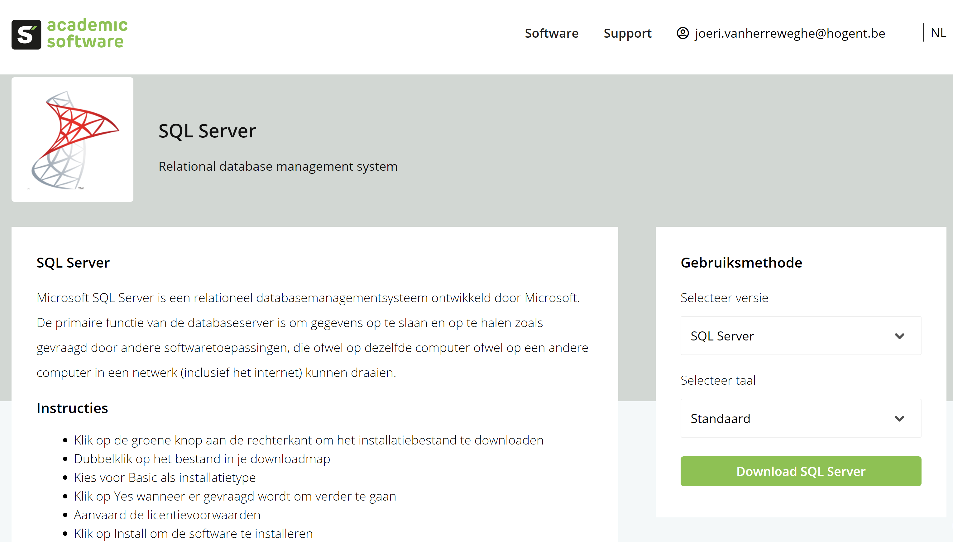

Follow the instructions. The *Developer* or *Standard* edition are sufficient for this course. The installation procedure for both versions is the same.

Run the setup and choose ‘Custom’ installation, then wait:

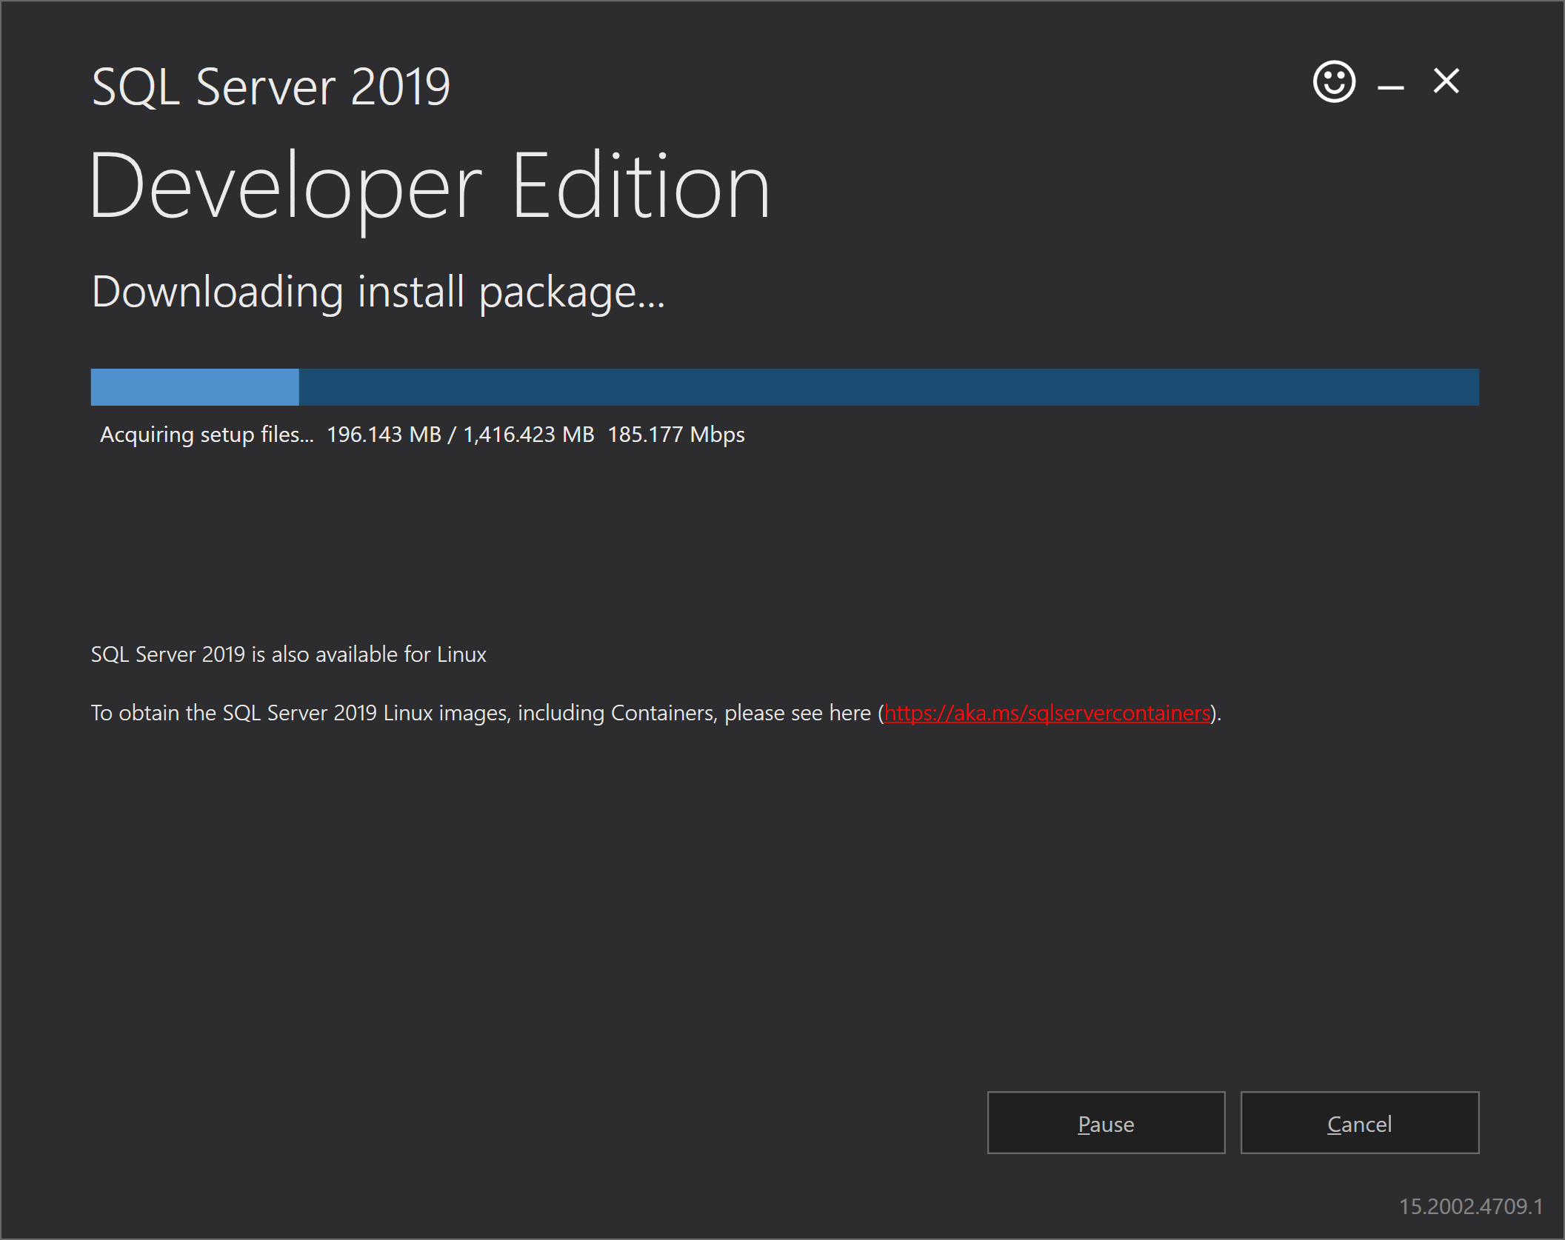

Go to installation and choose ‘New SQL Server stand-alone installation or add features to an existing installation”.

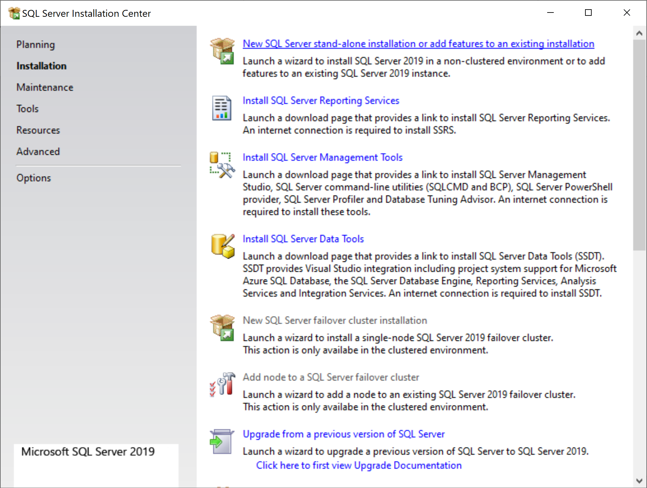

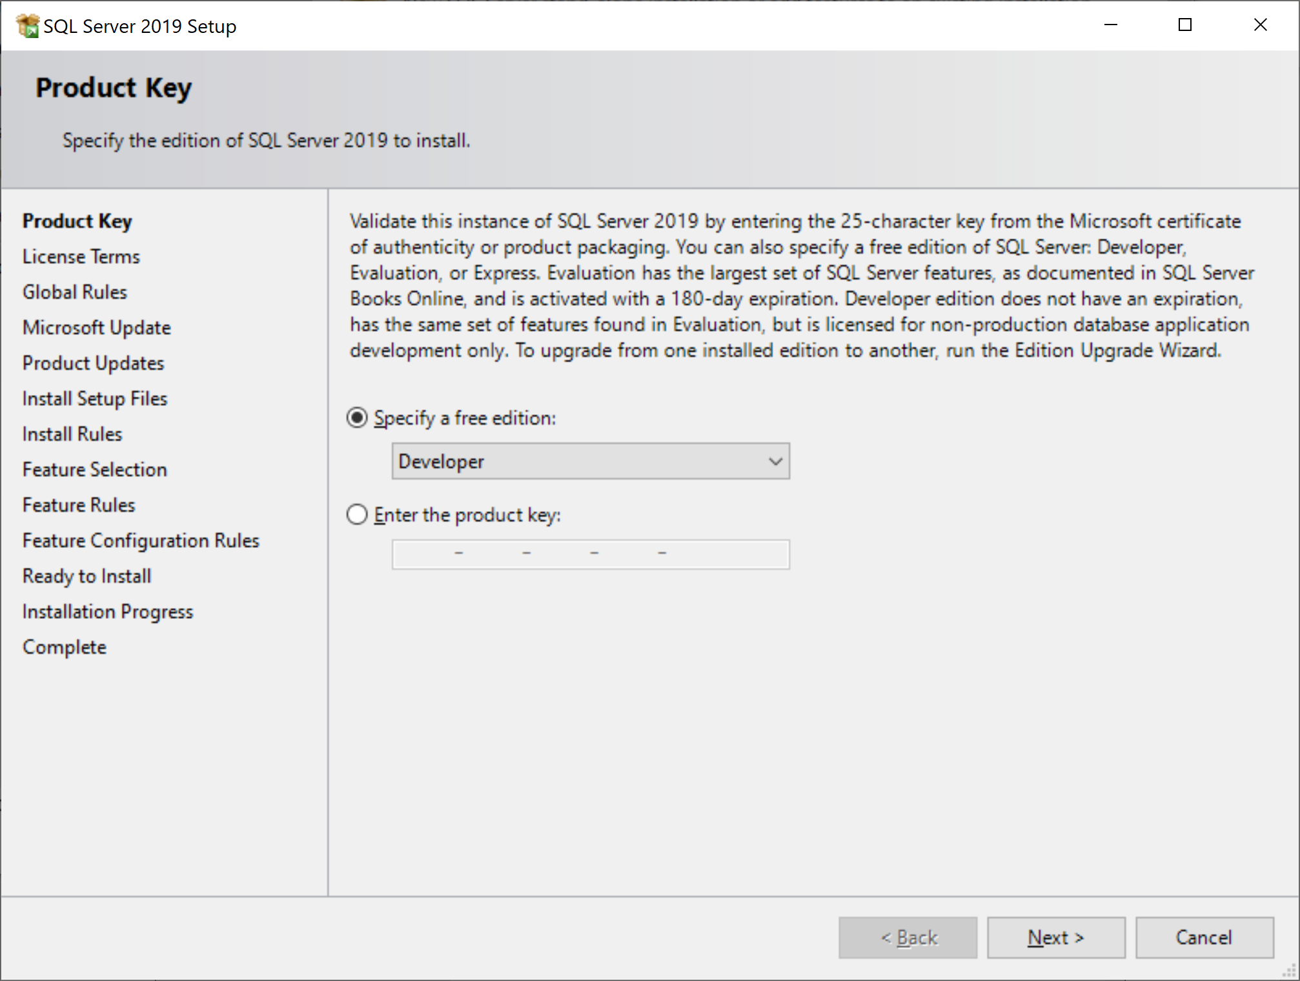

Choose developer: this has no expiration date.

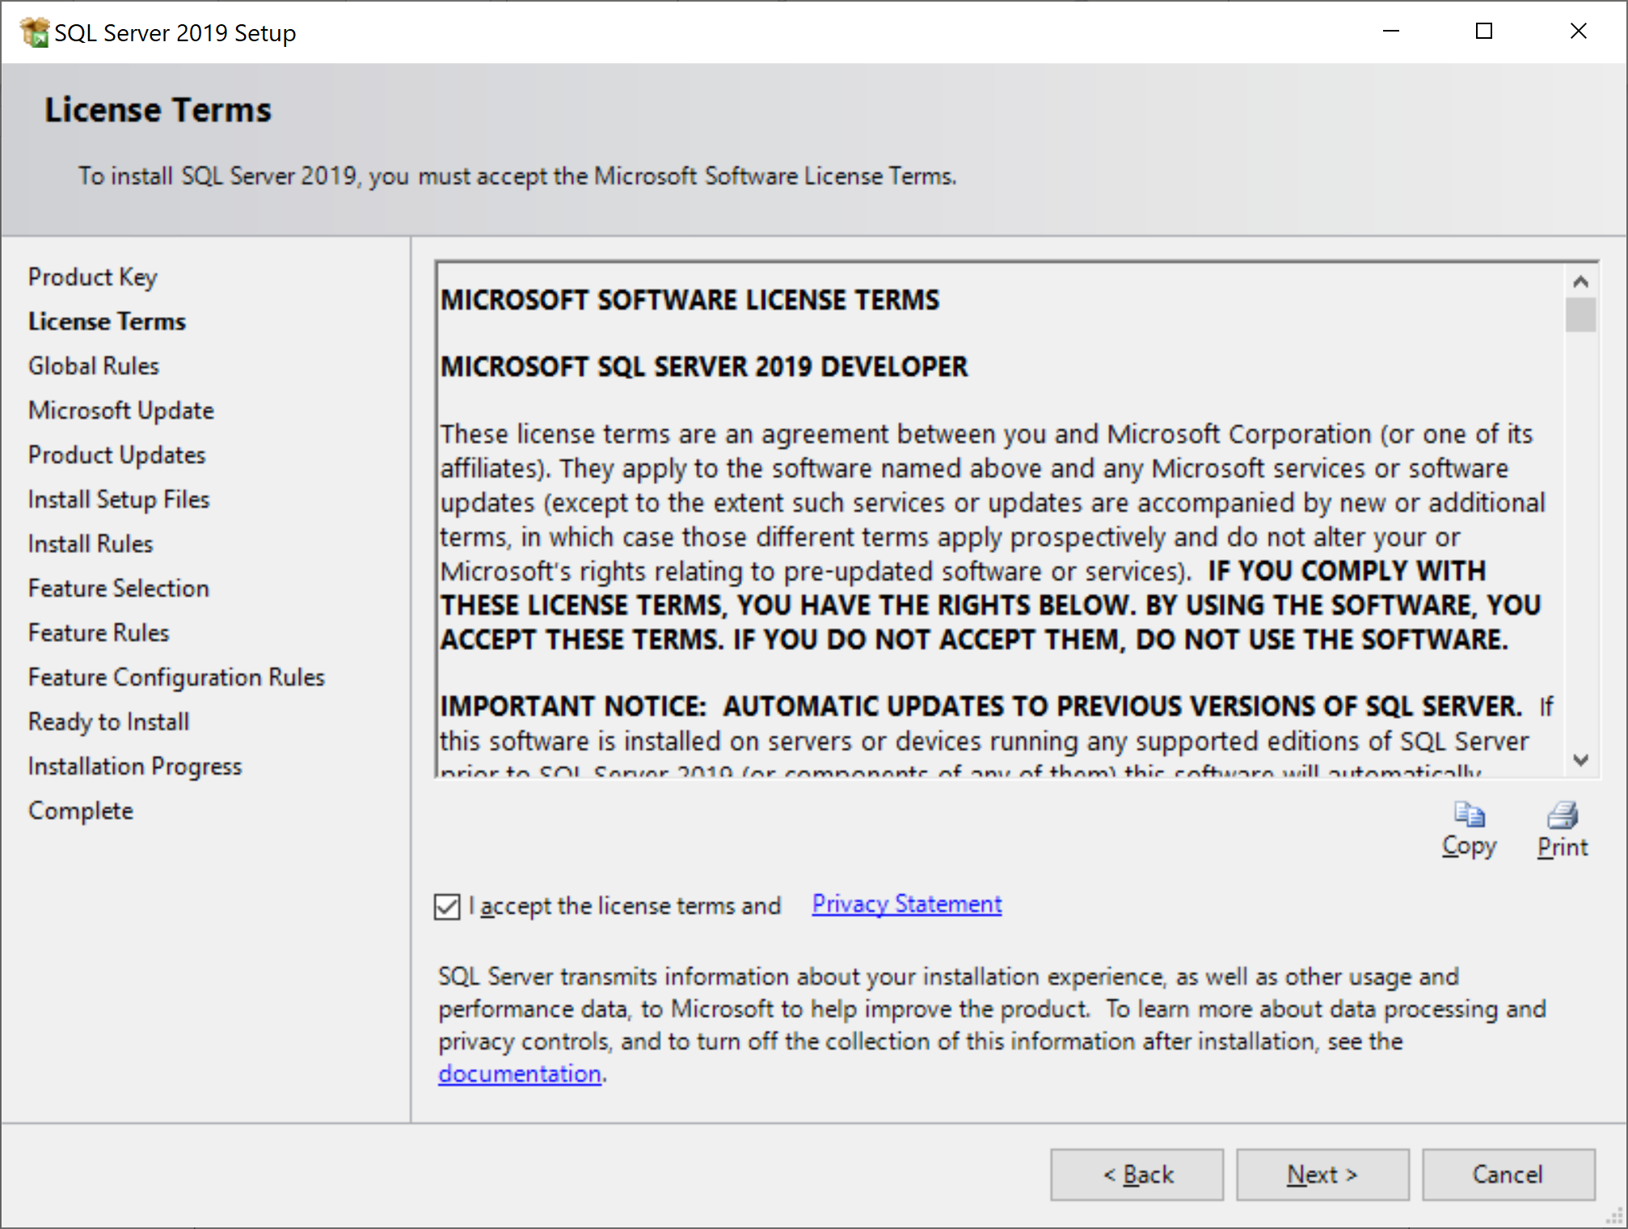

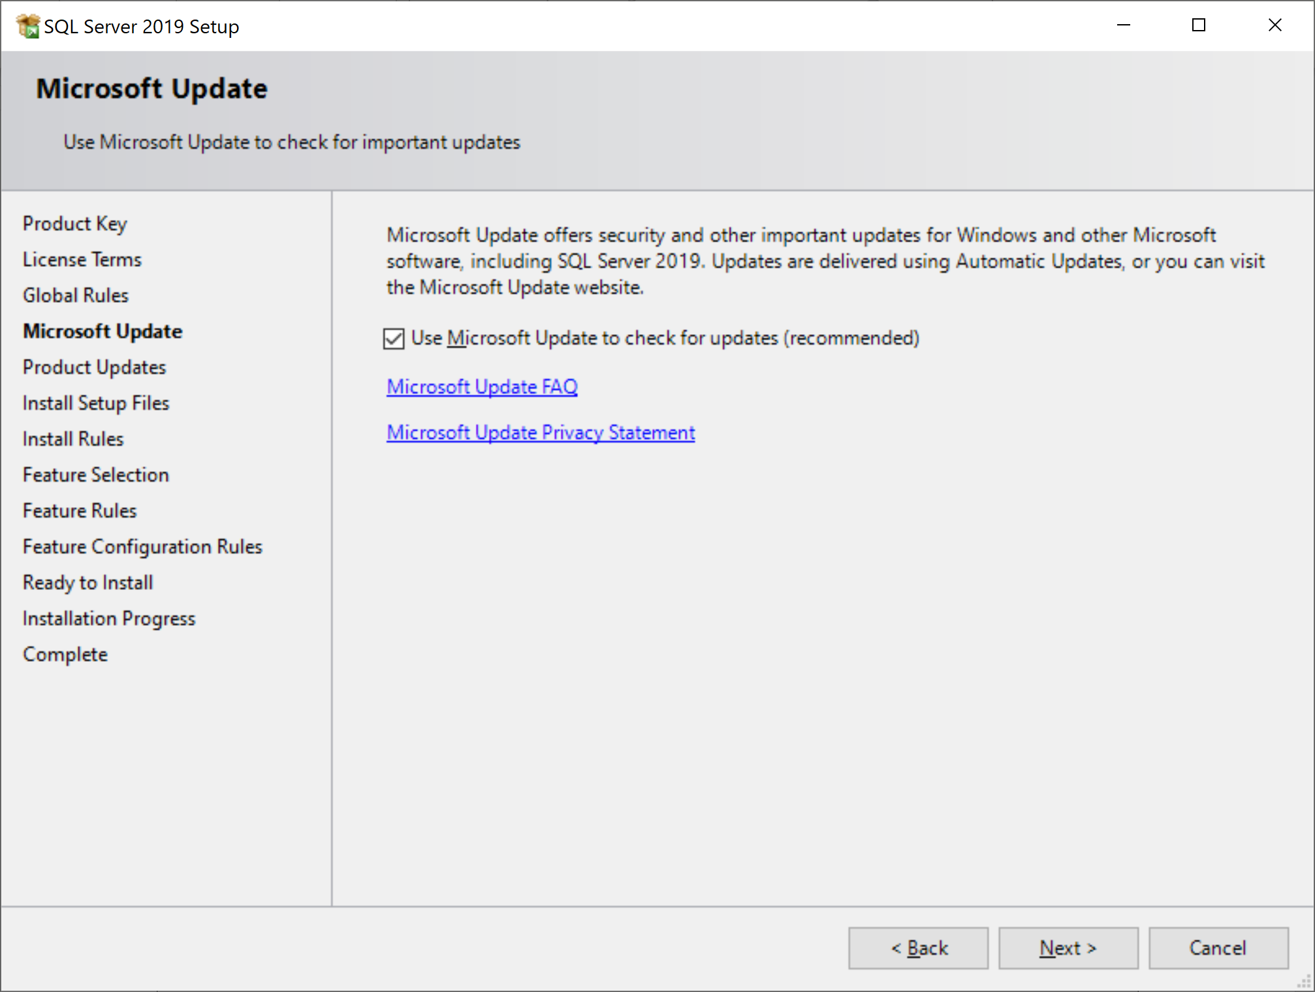

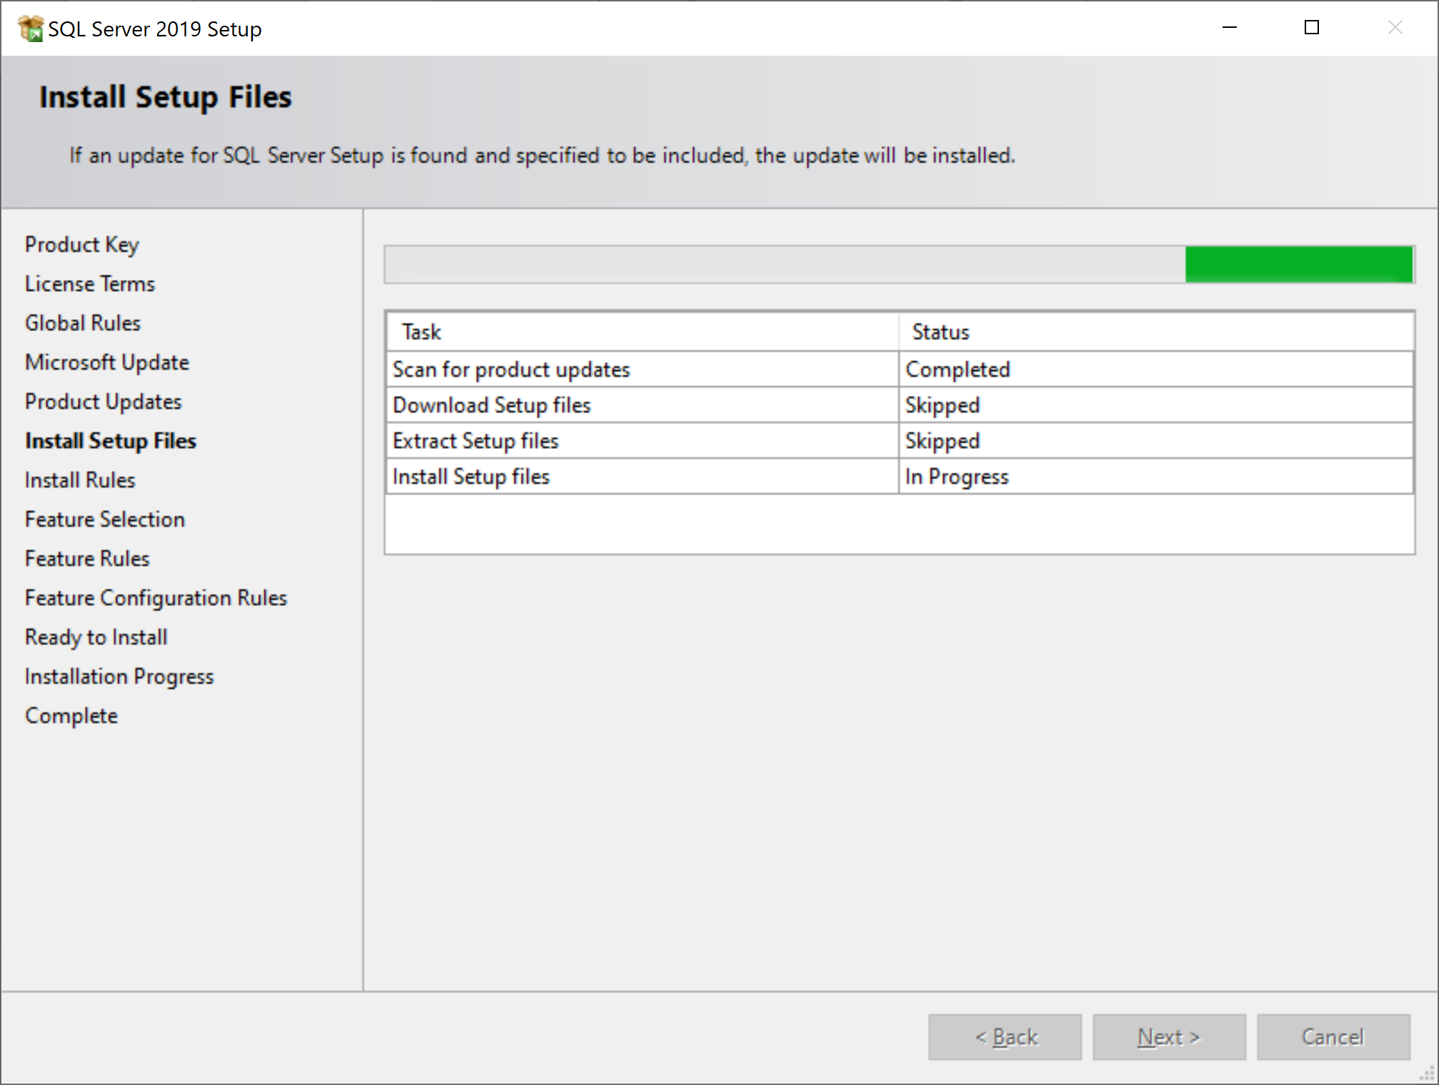

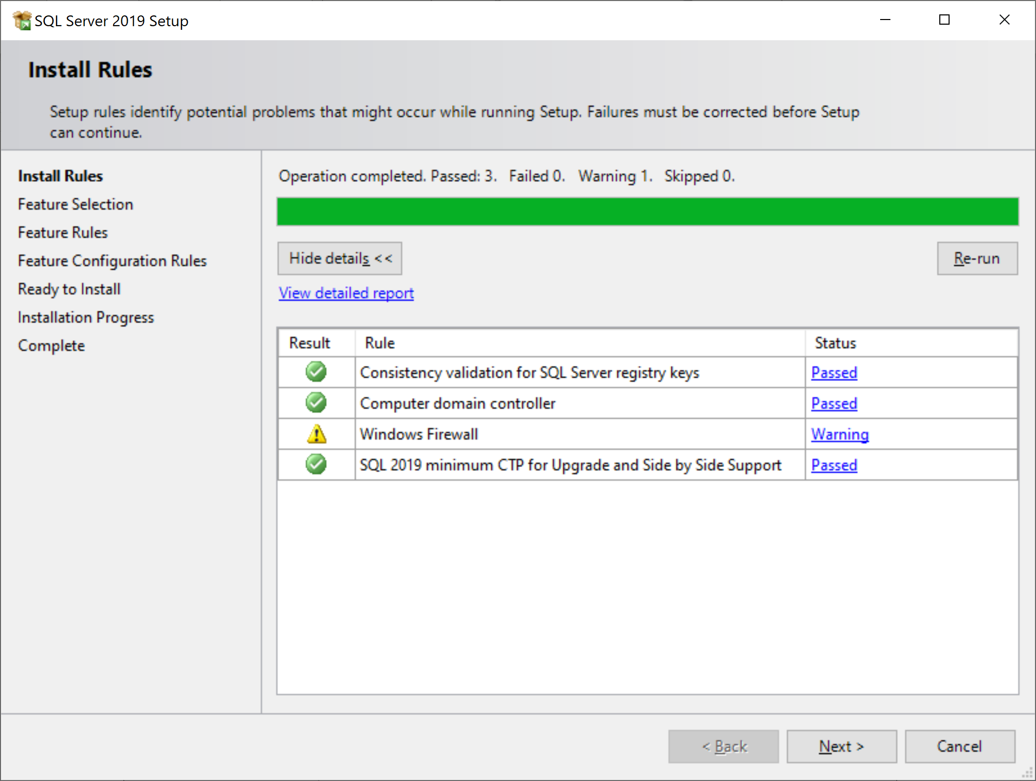

Hit next.

Now choose your Features. Please pay close attention:

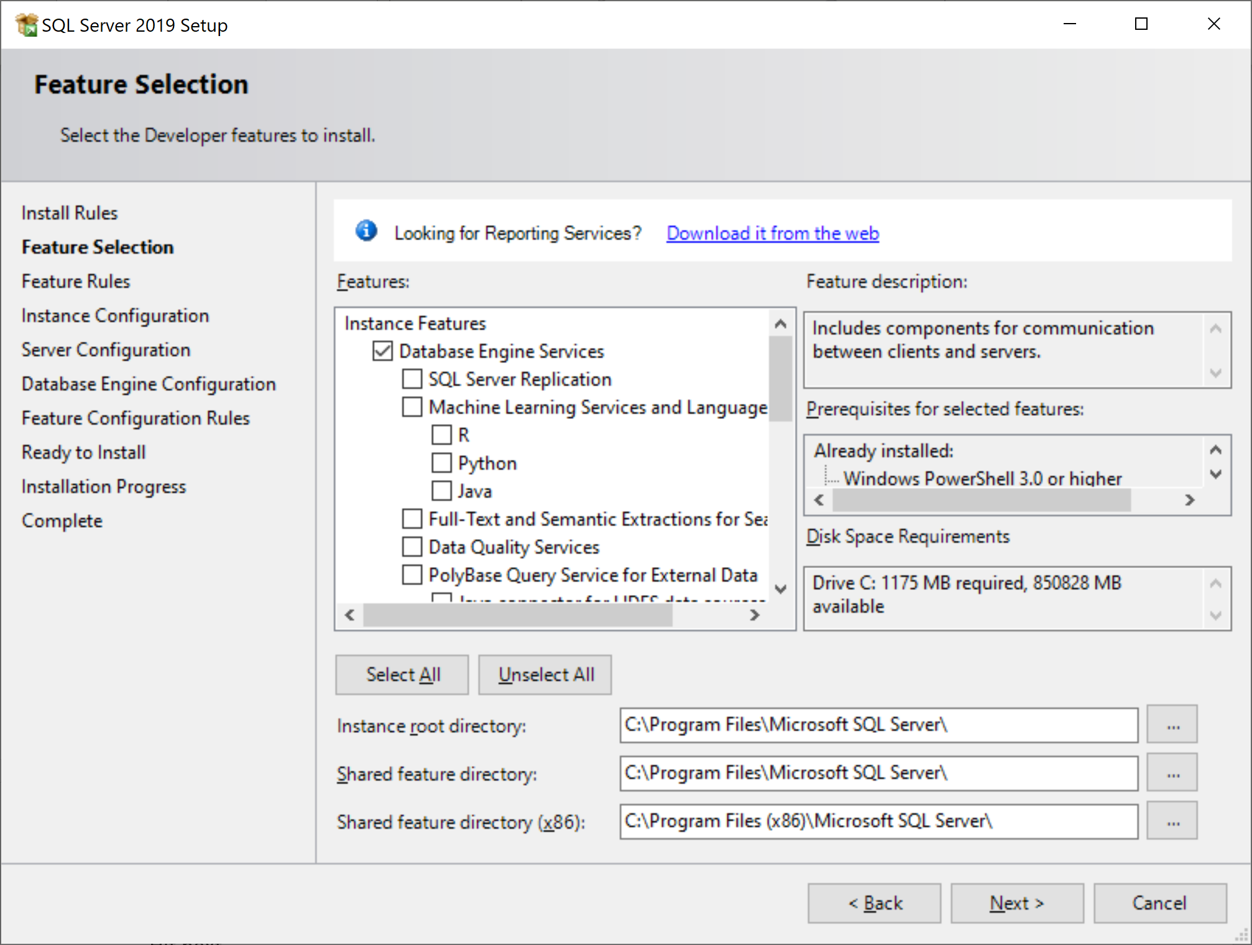

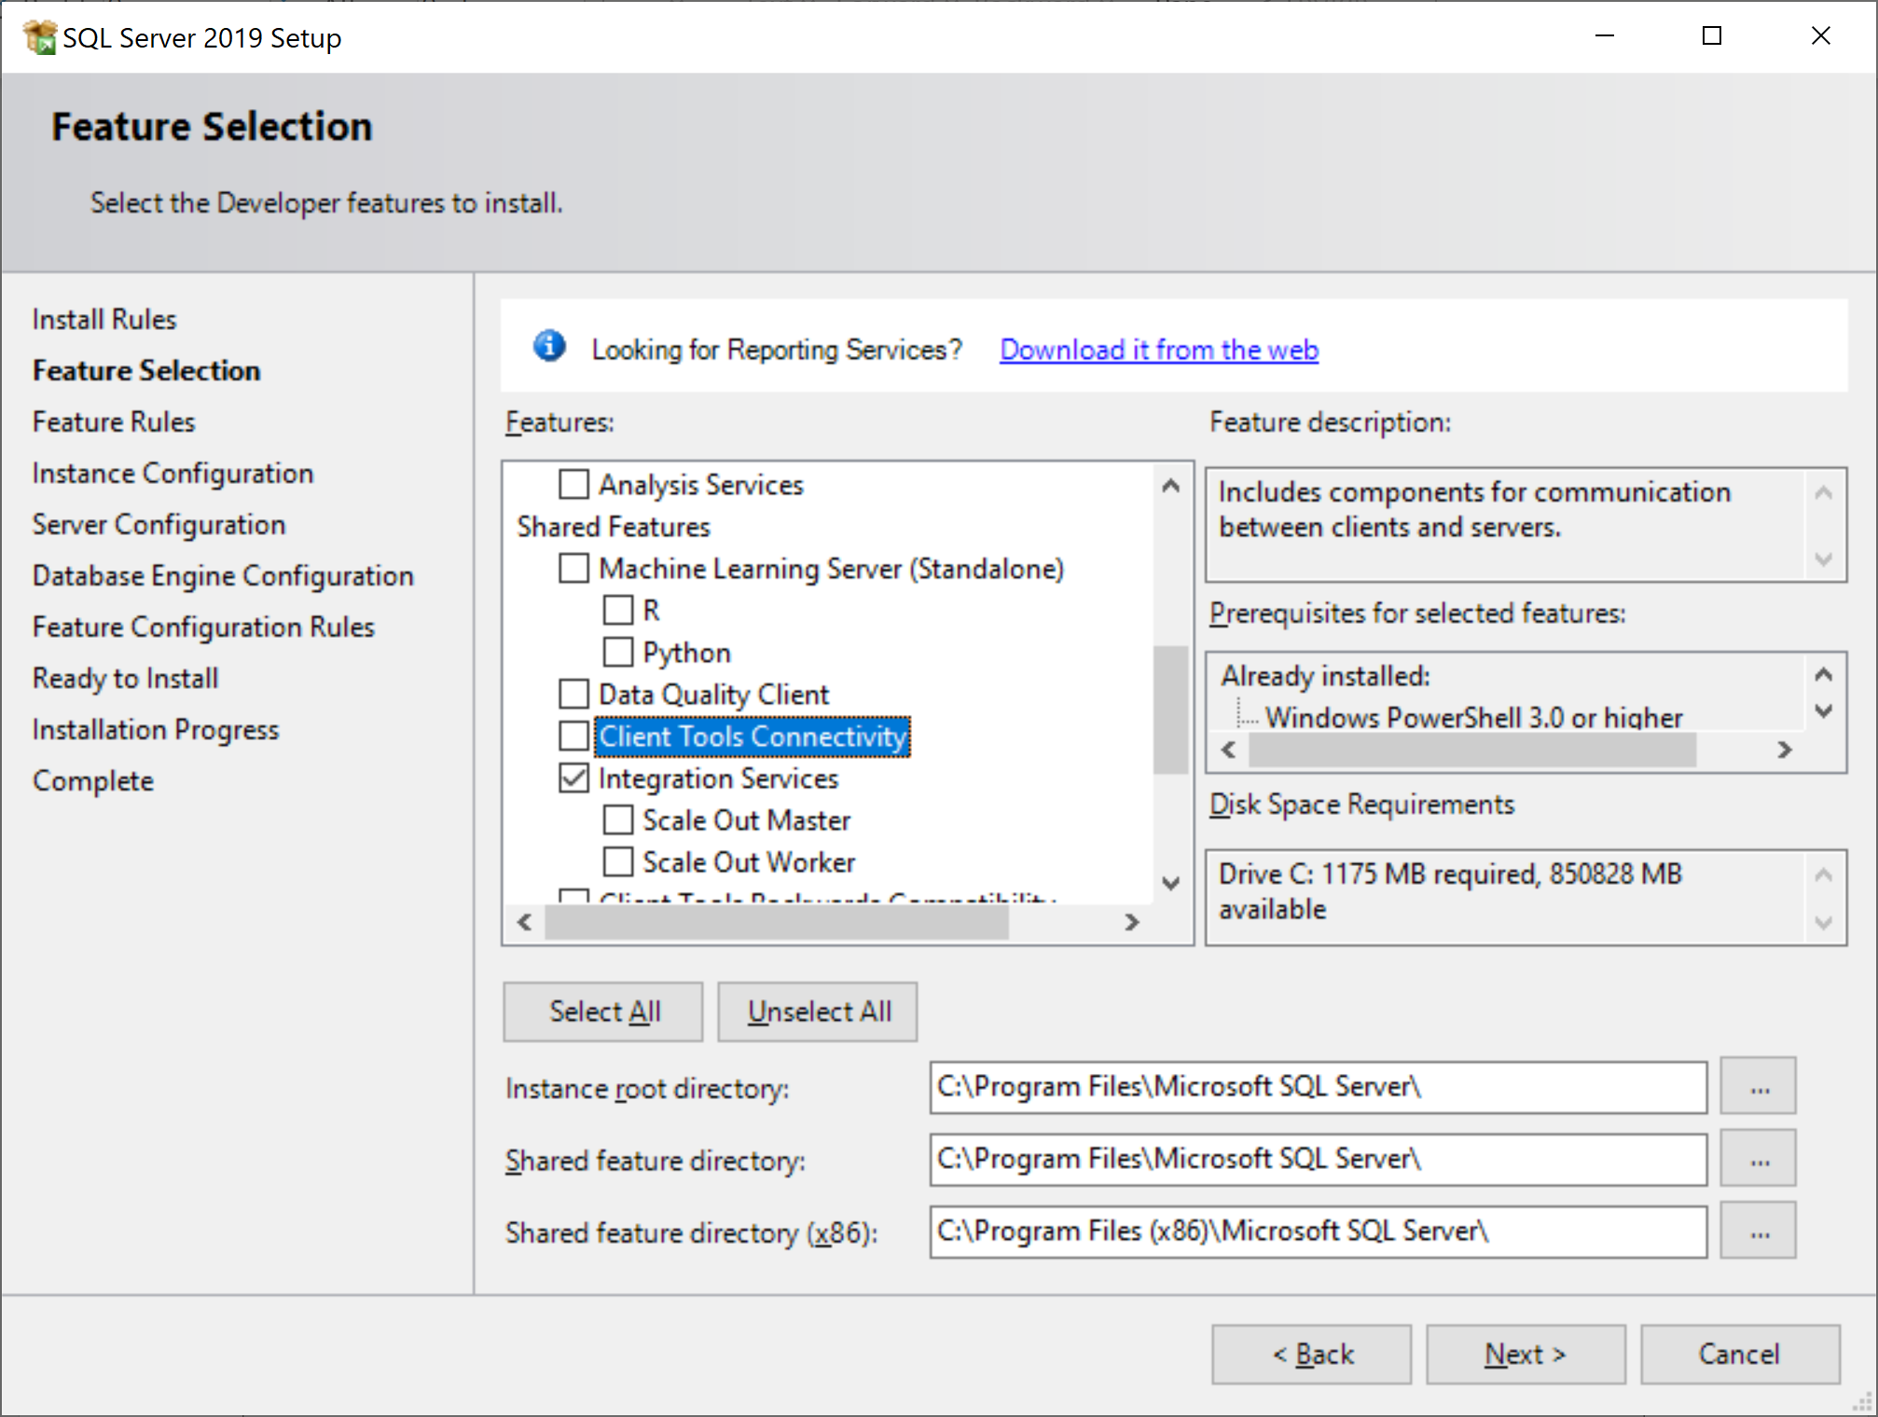

Then click Next.

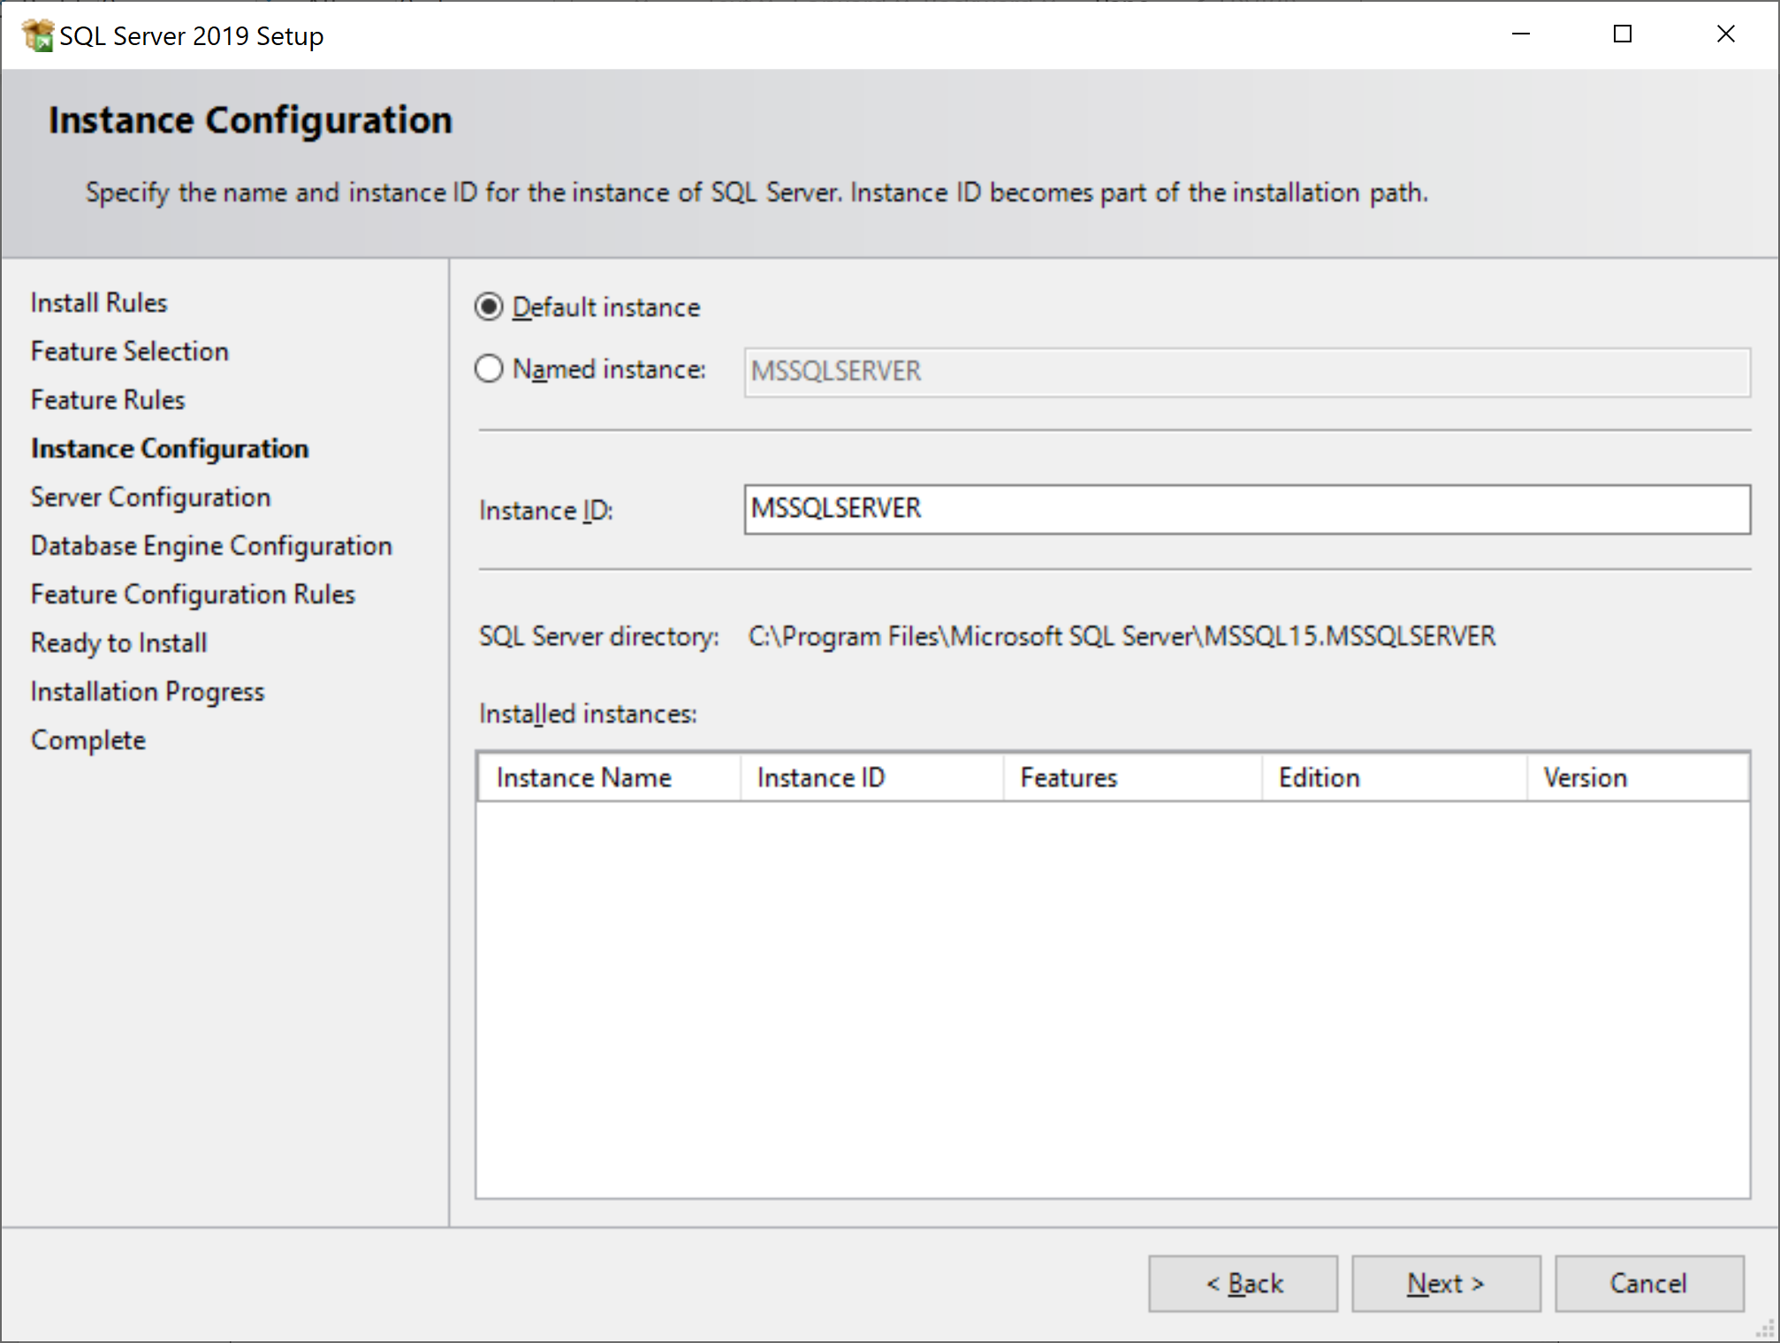

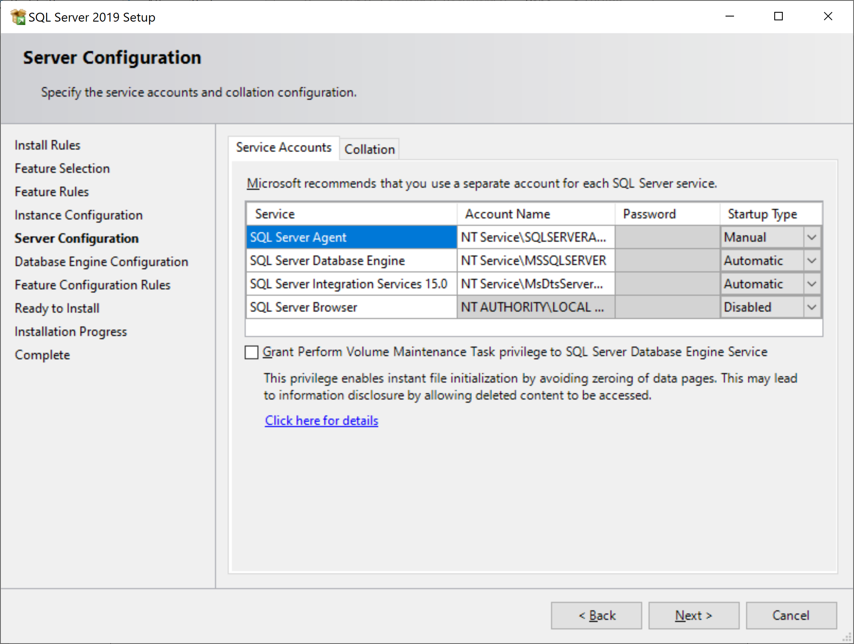

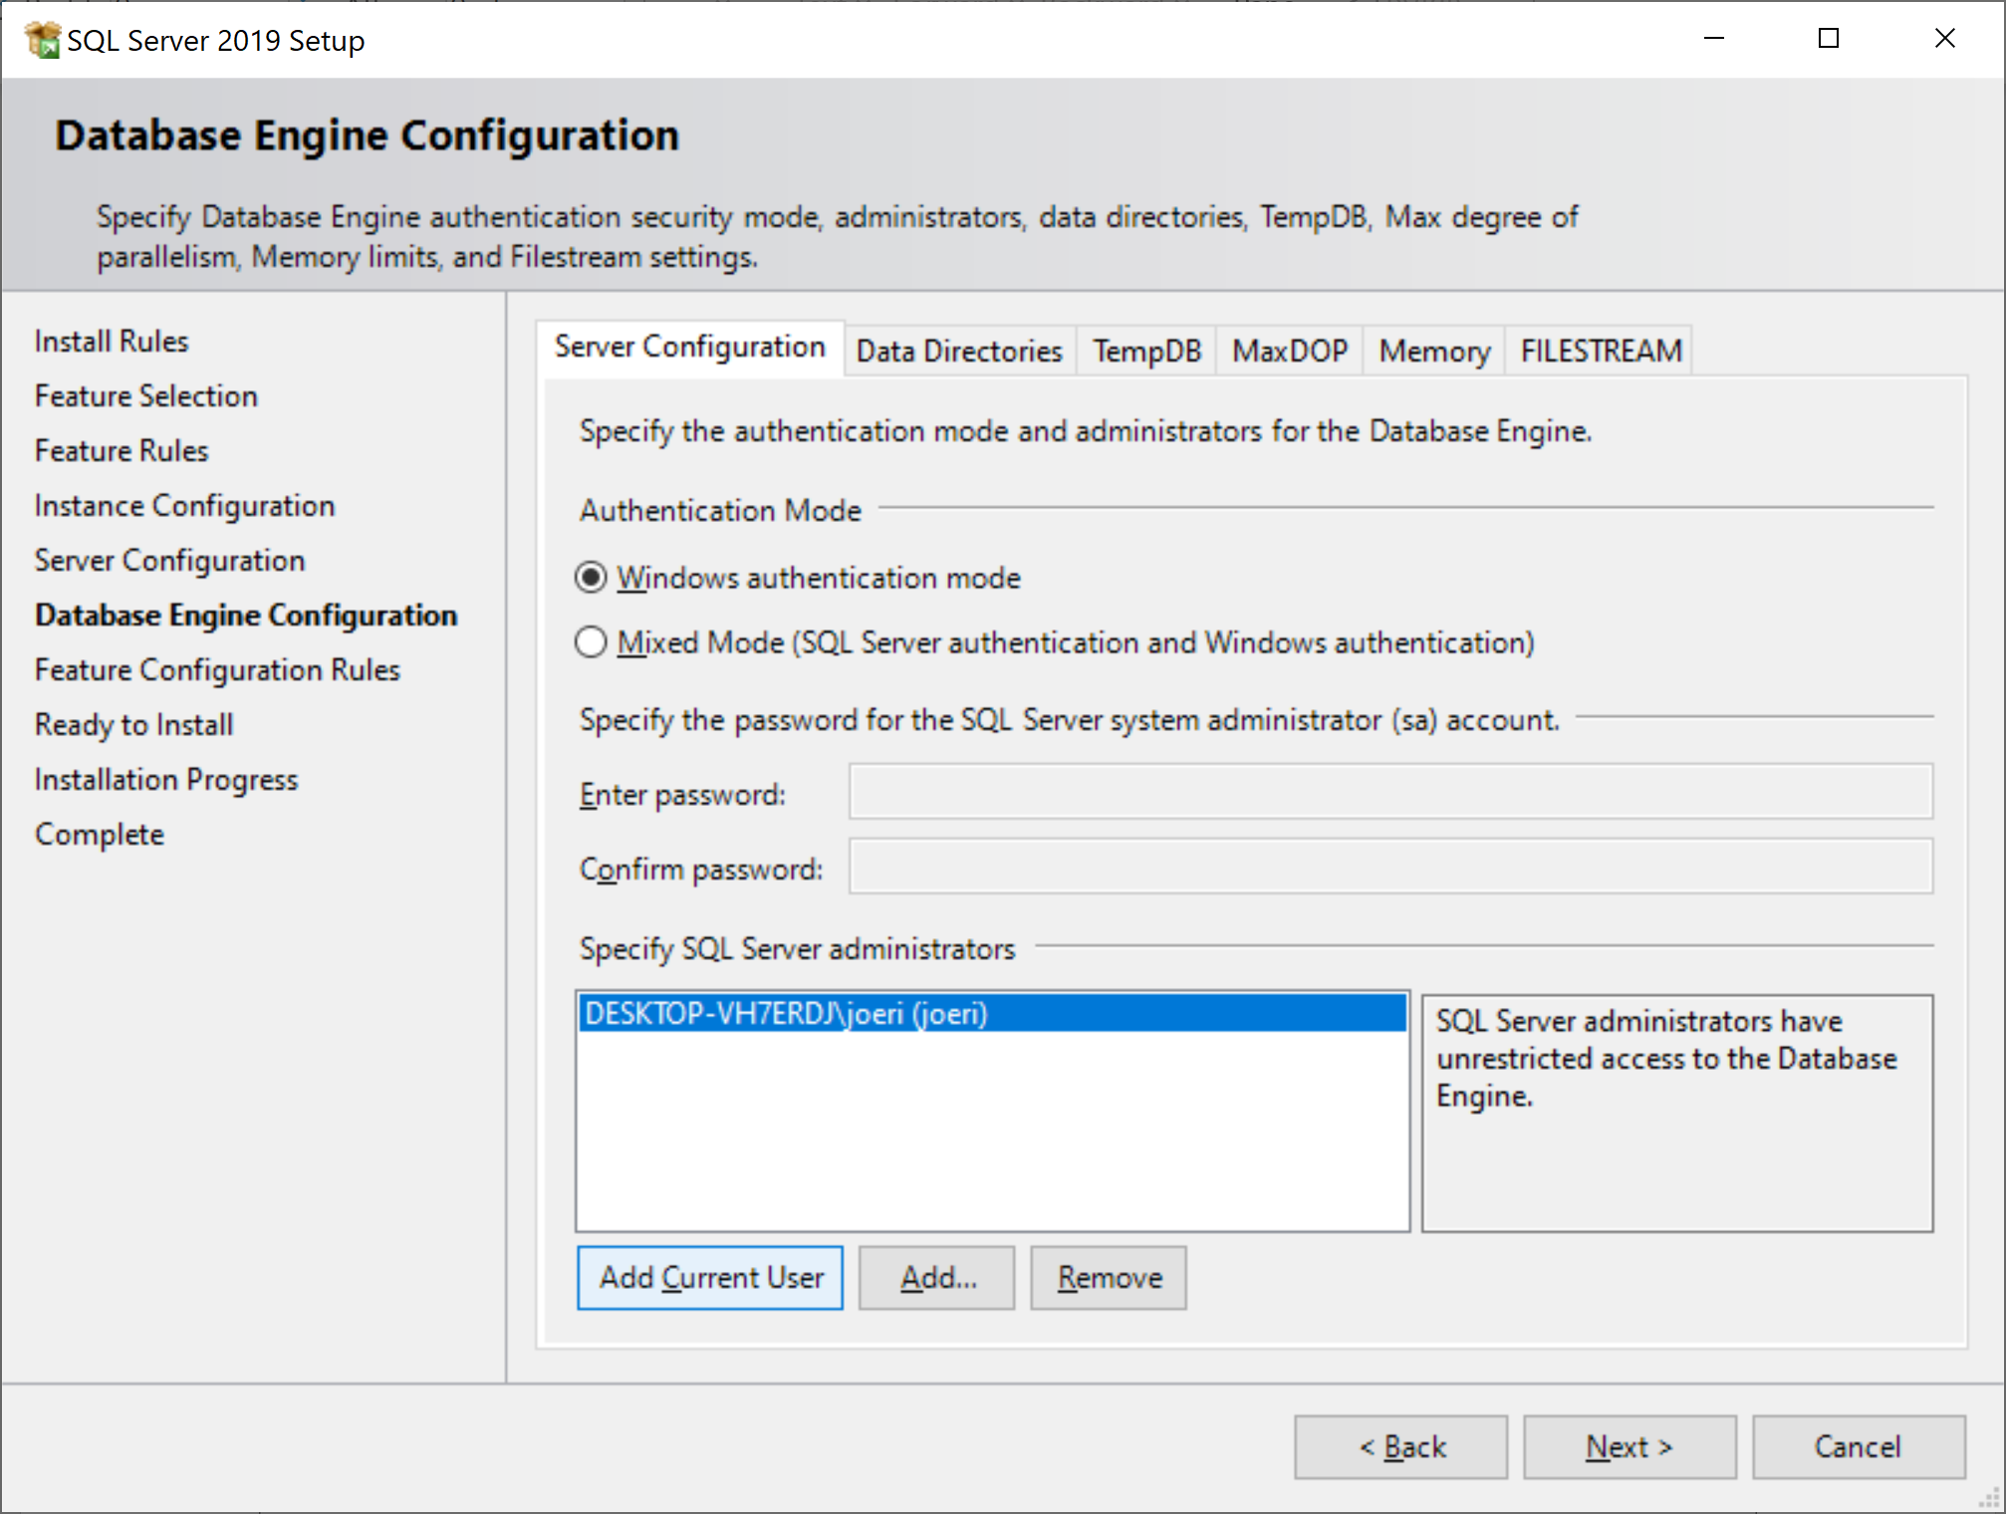

Click ‘Add Current User’ and then ‘Next’!

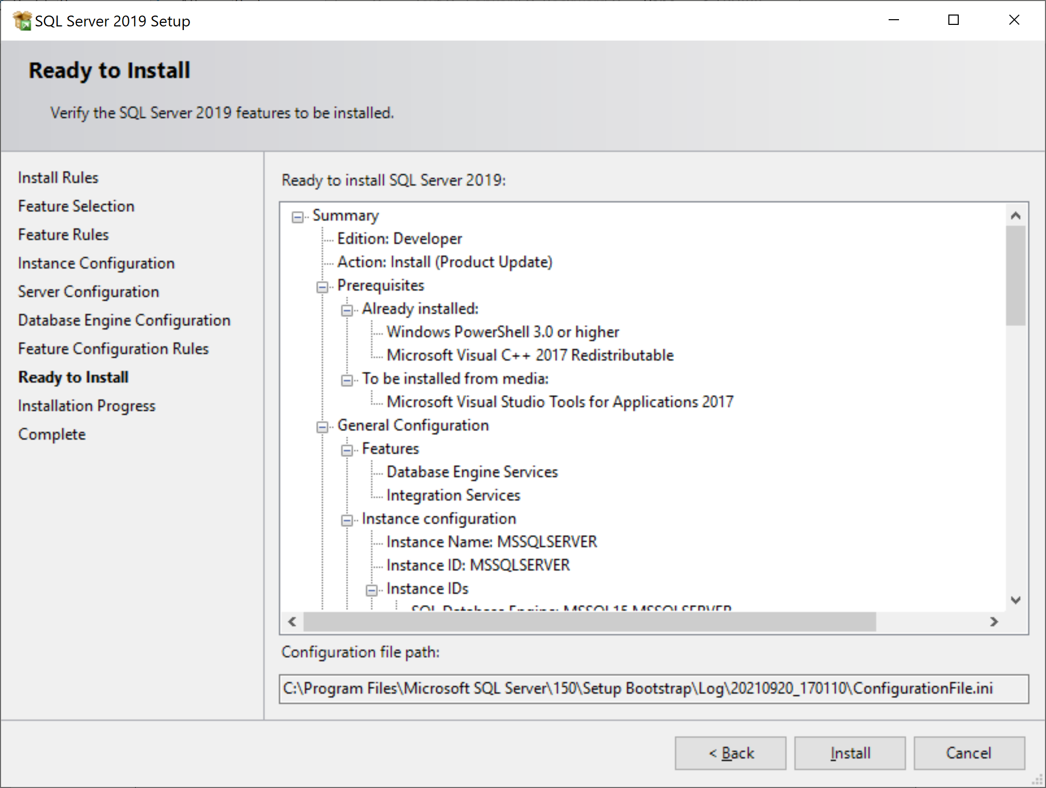

Click Install to do the installation of all chosen features.

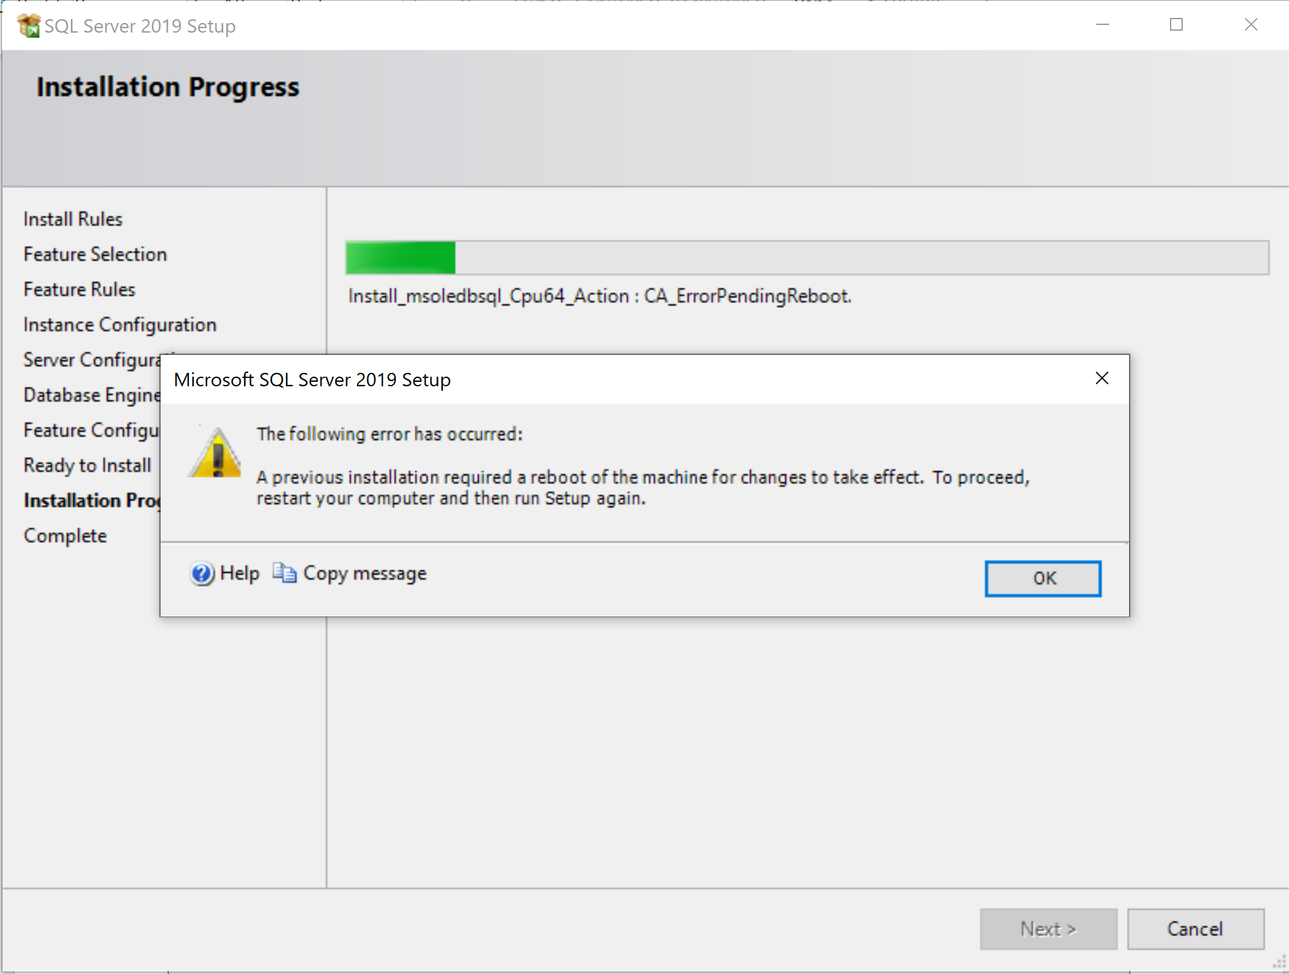

If is possible that you will receive an error while installing. Just click ‘OK’ if this error shows up.

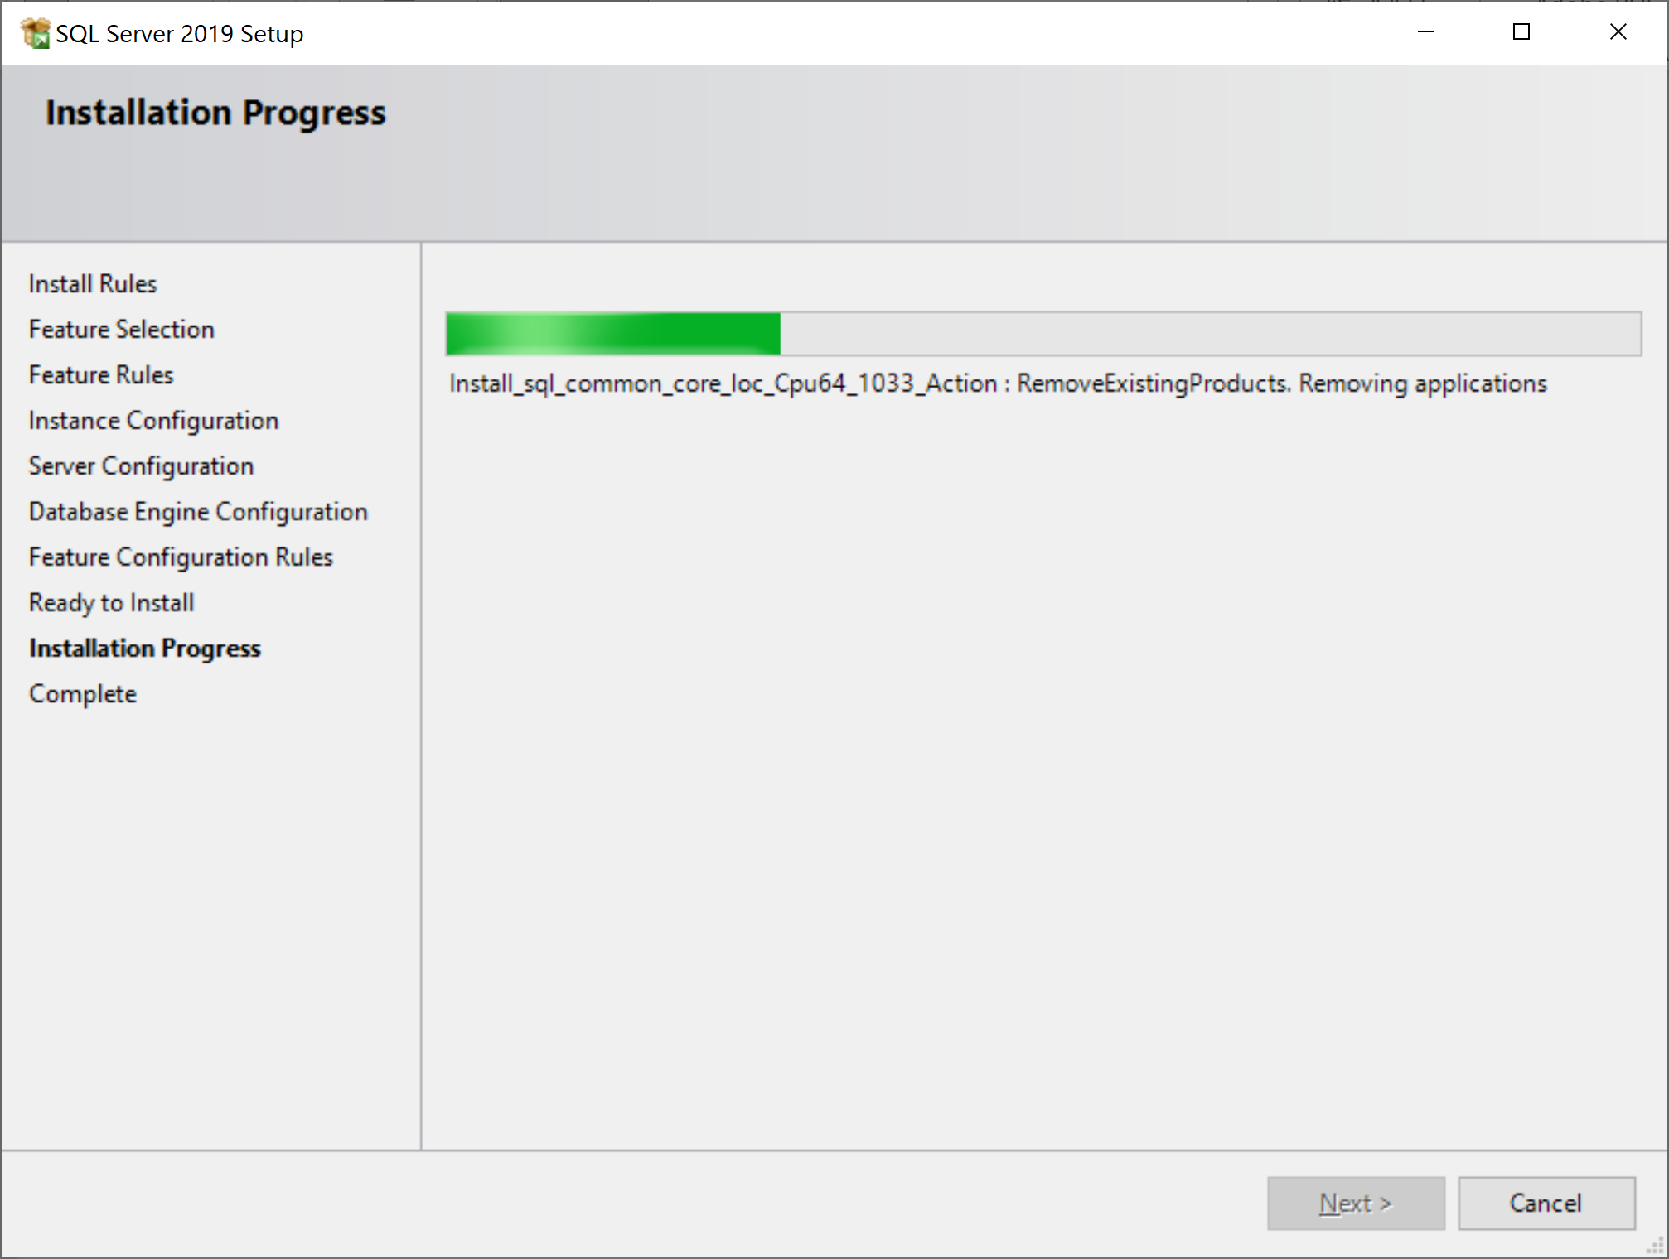

Setup will continue with the installation of the other features.

If no error appeared, you are lucky and can skip to the “Installation of SQL Server Management Studio (SSMS)”. If another error appeared, trouble shoot (Google is your friend). The next steps show how to solve the error above.

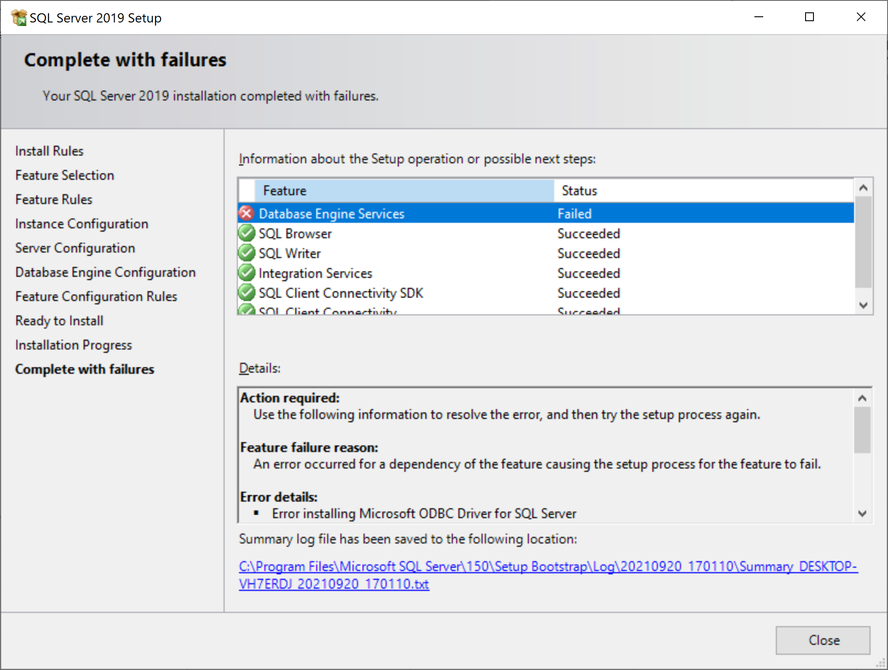

Due to previous error, it is possible that not all features are installed. In that case you have to reboot and rerun the setup.

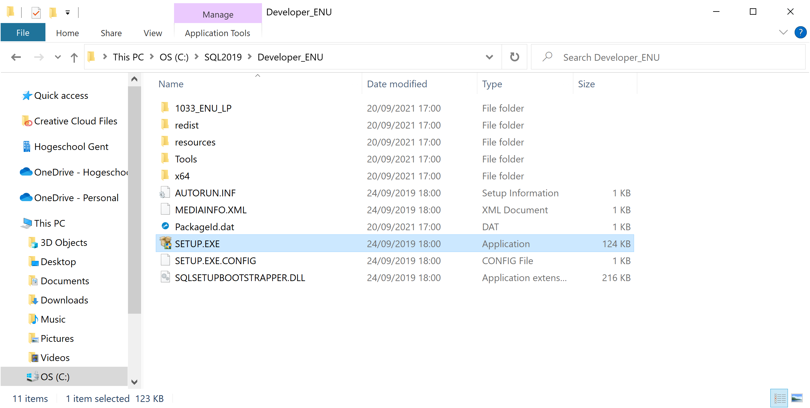

Run SETUP.EXE and do exactly the same as previously.

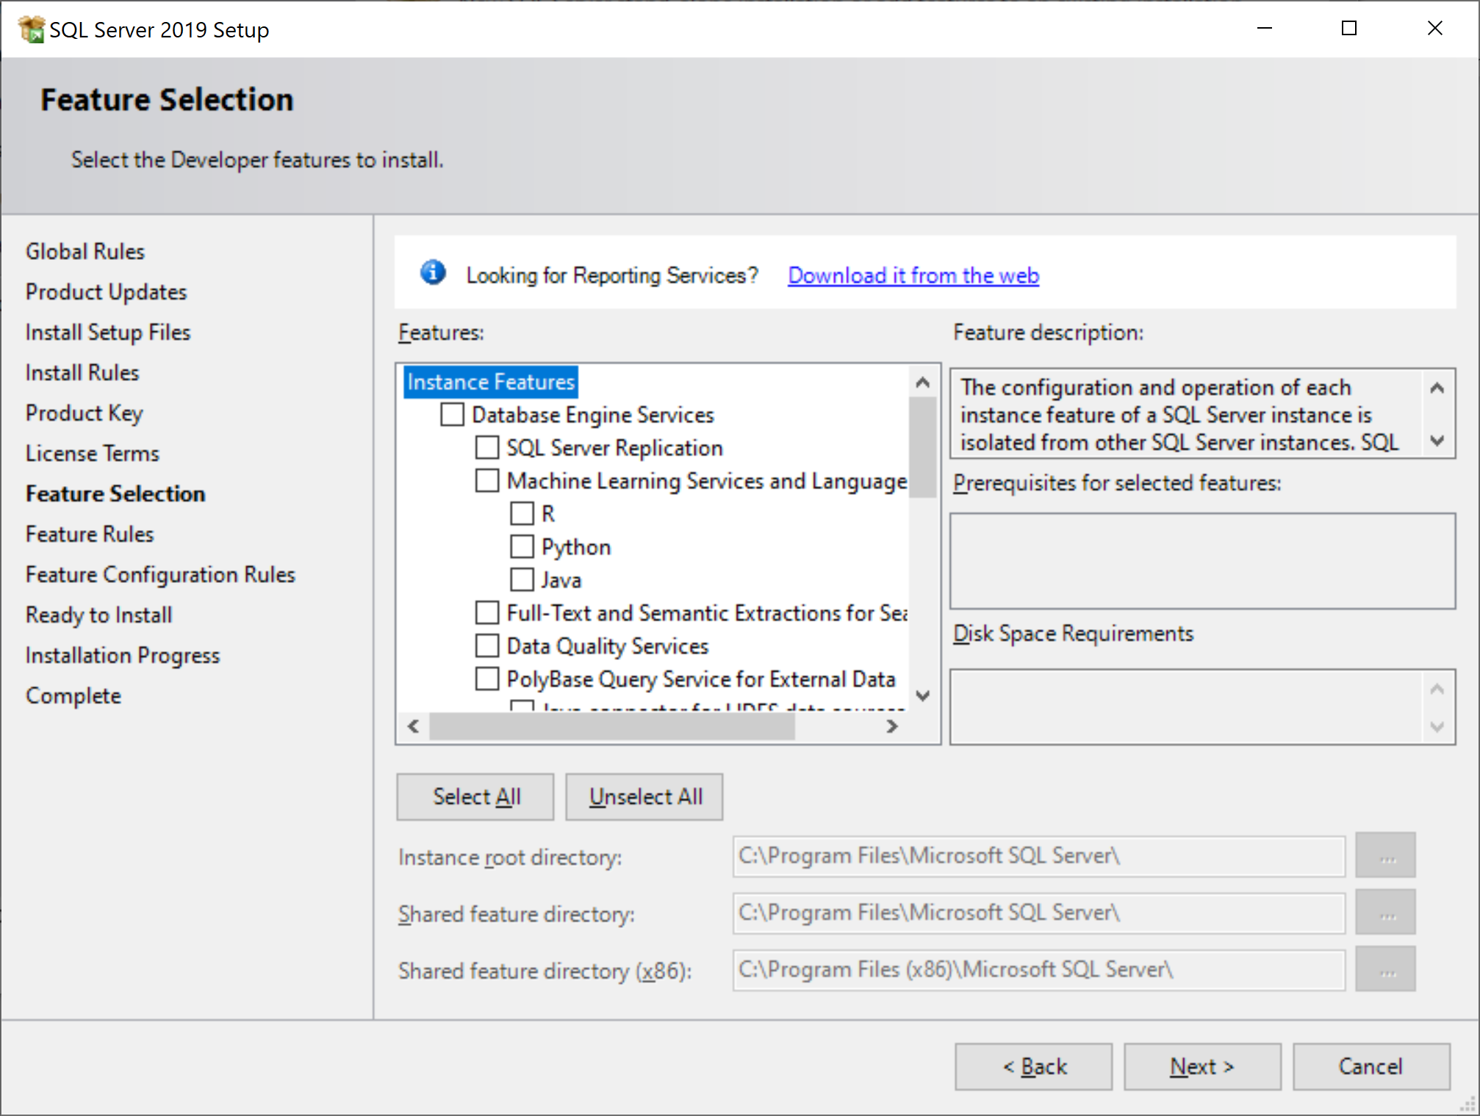

You will notice that the feature that has failed is unchecked. **Check the checkbox** (‘Database Engine Service’), and click ‘Next’.

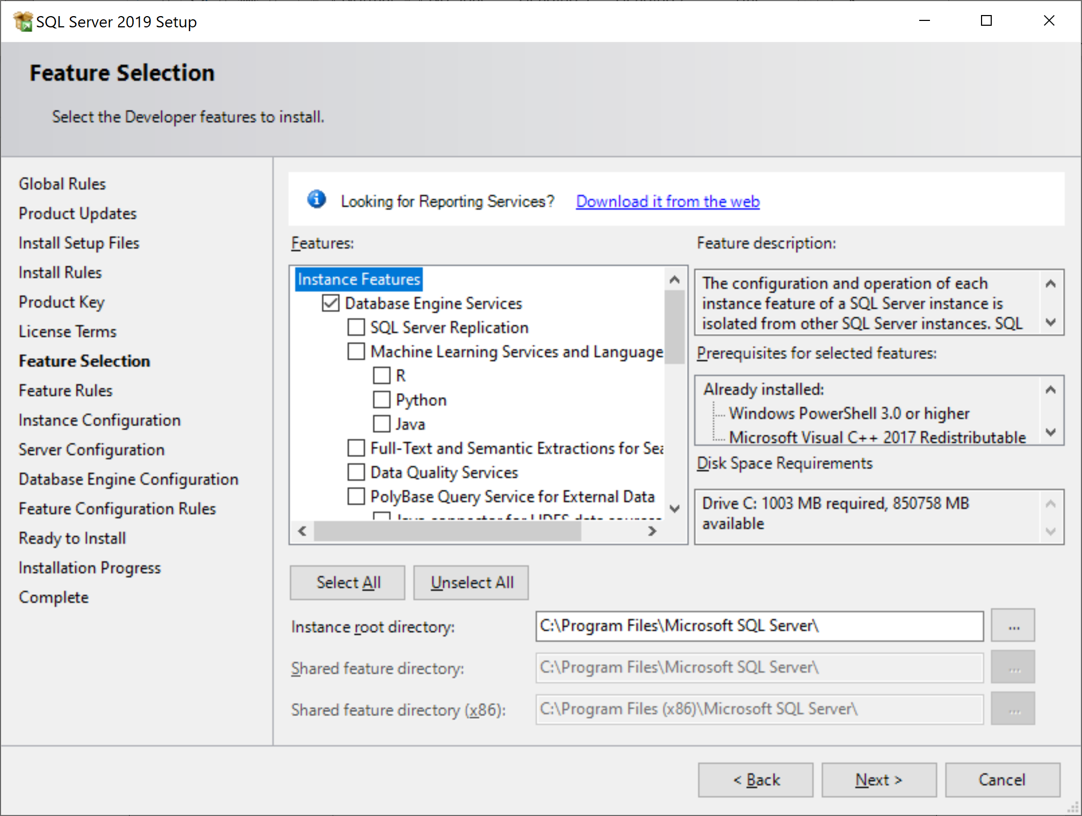

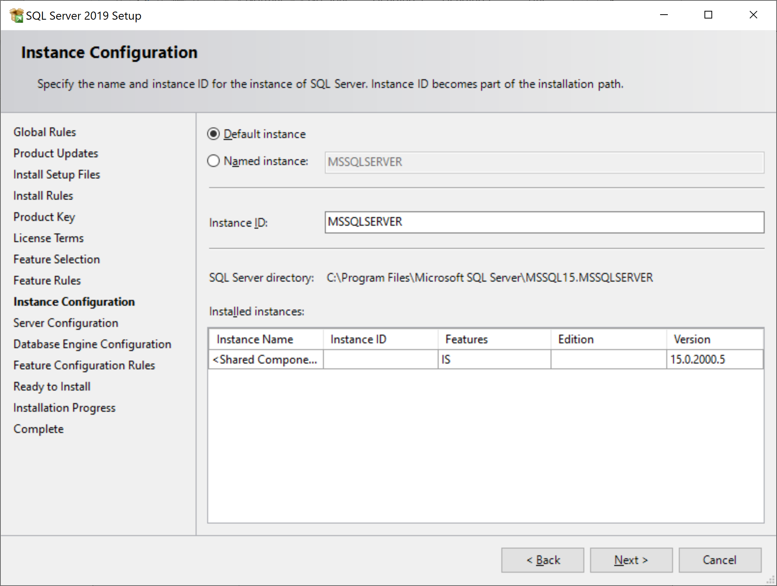

Choose ‘Default Instance’ again.

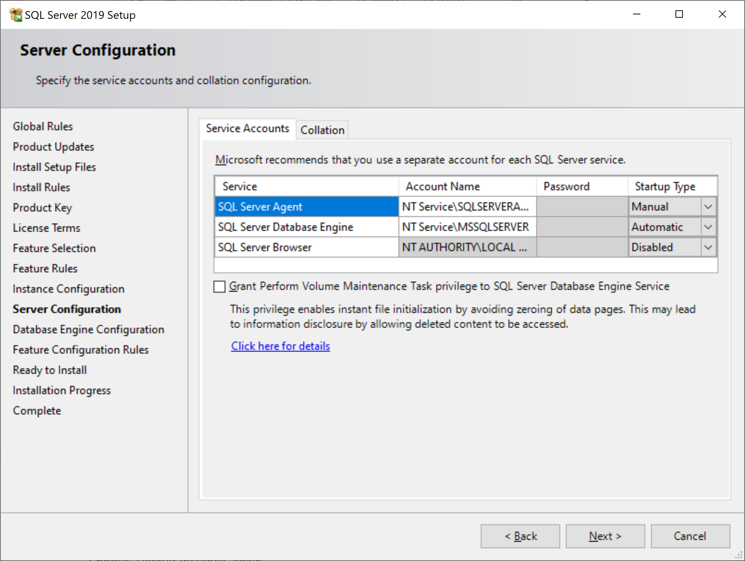

Next

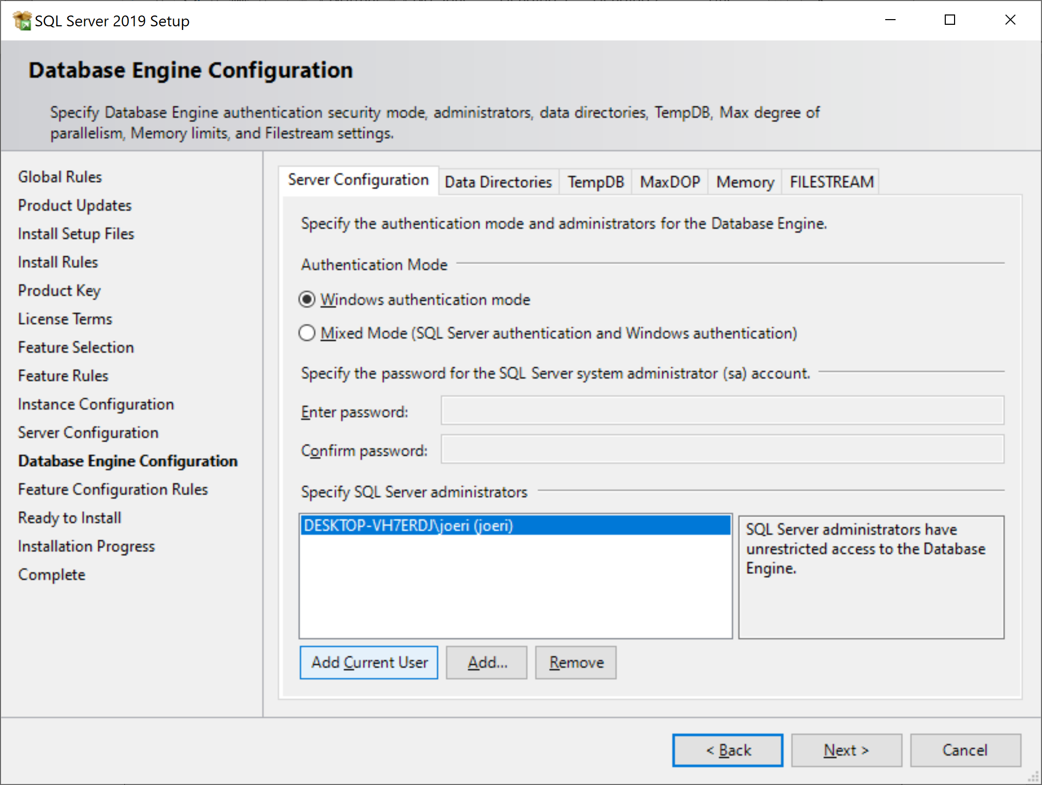

‘Add Current User’, ‘Next’.

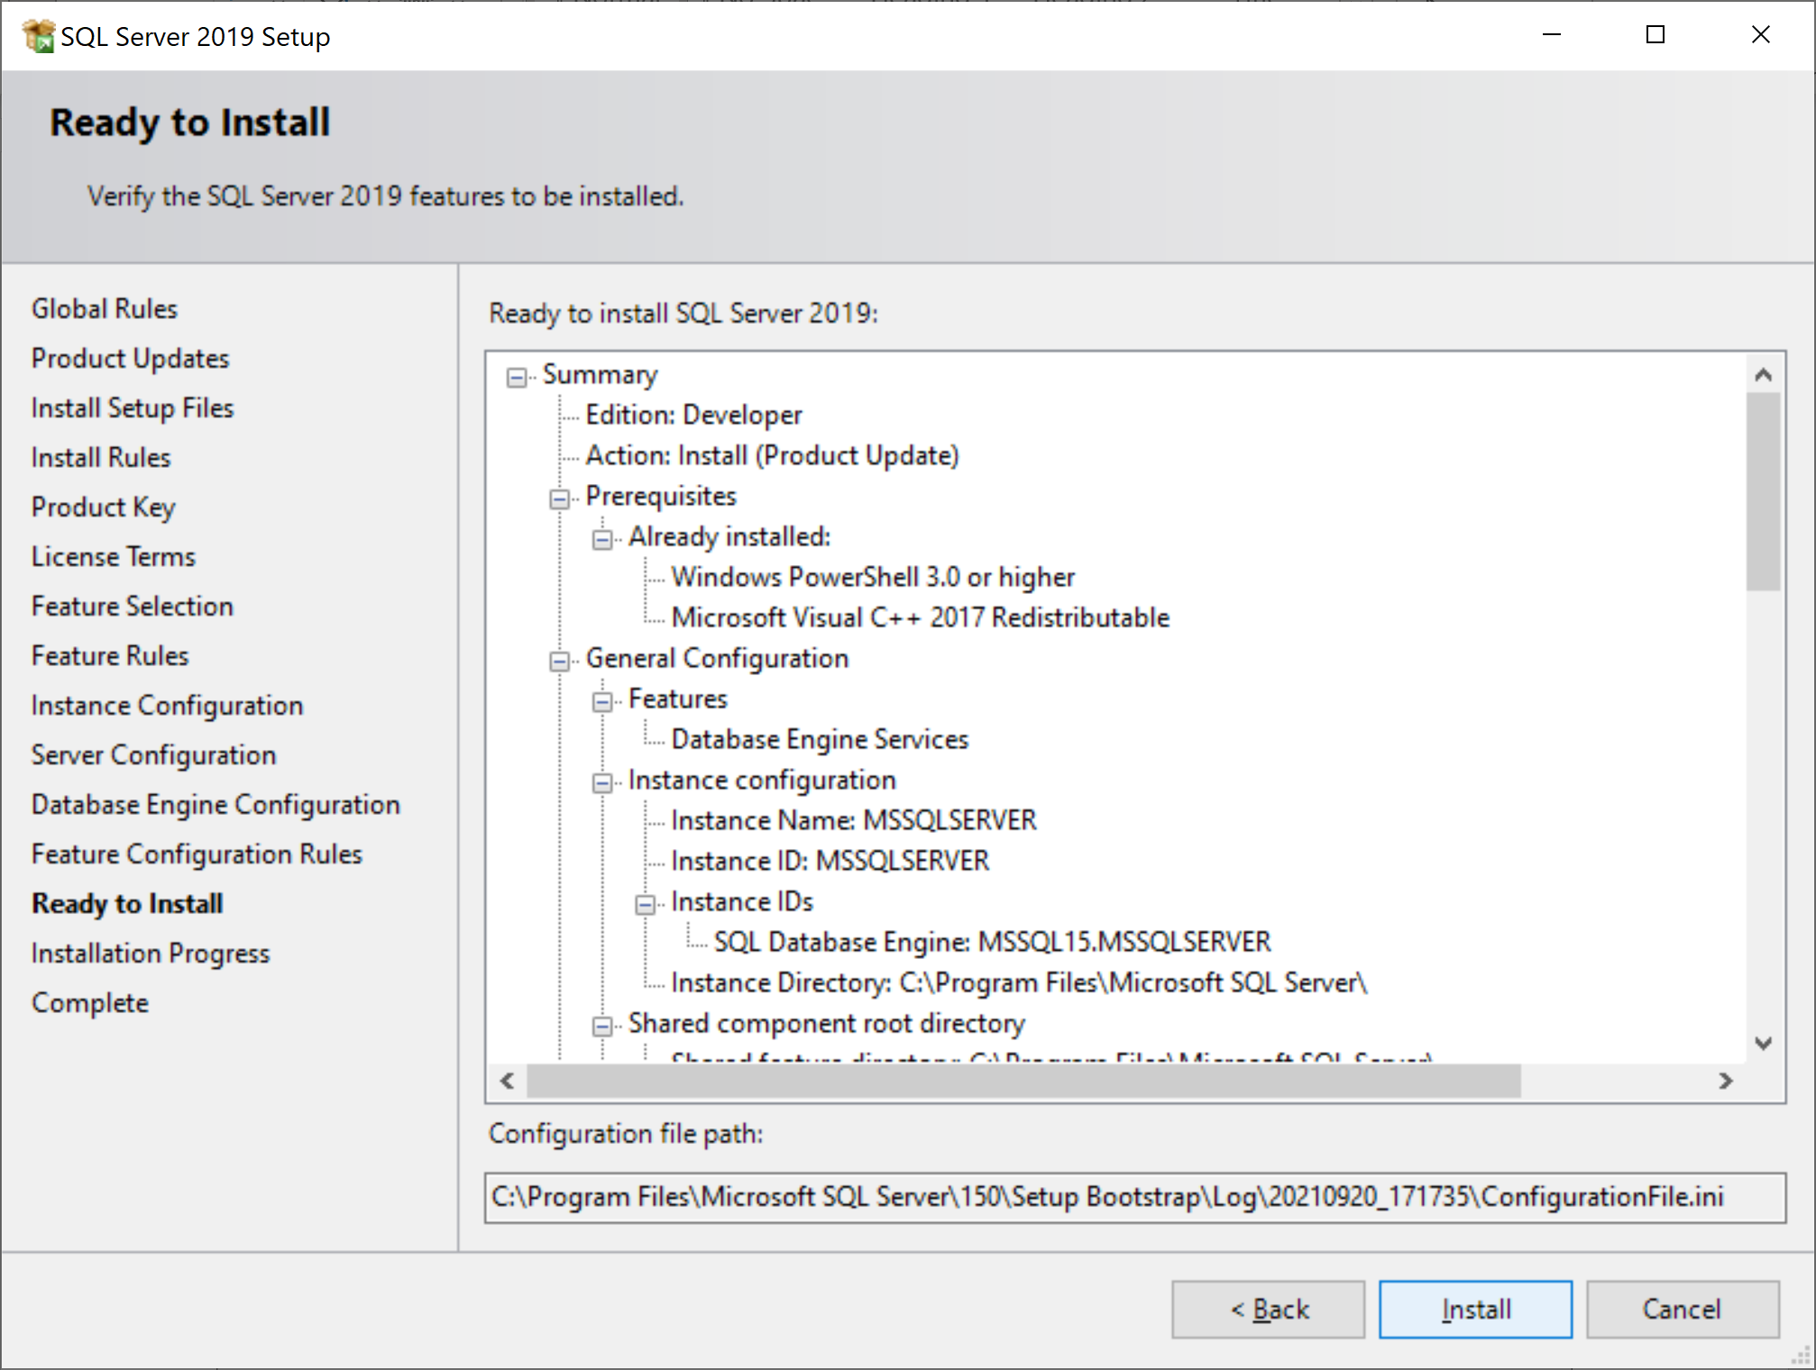  
Install and keep your fingers crossed 😉

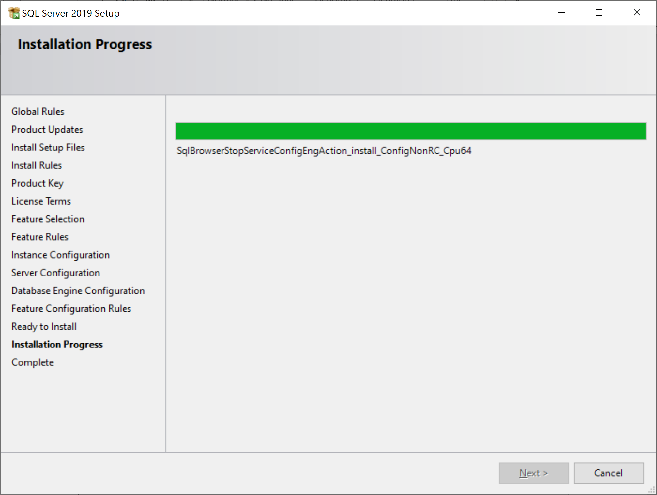

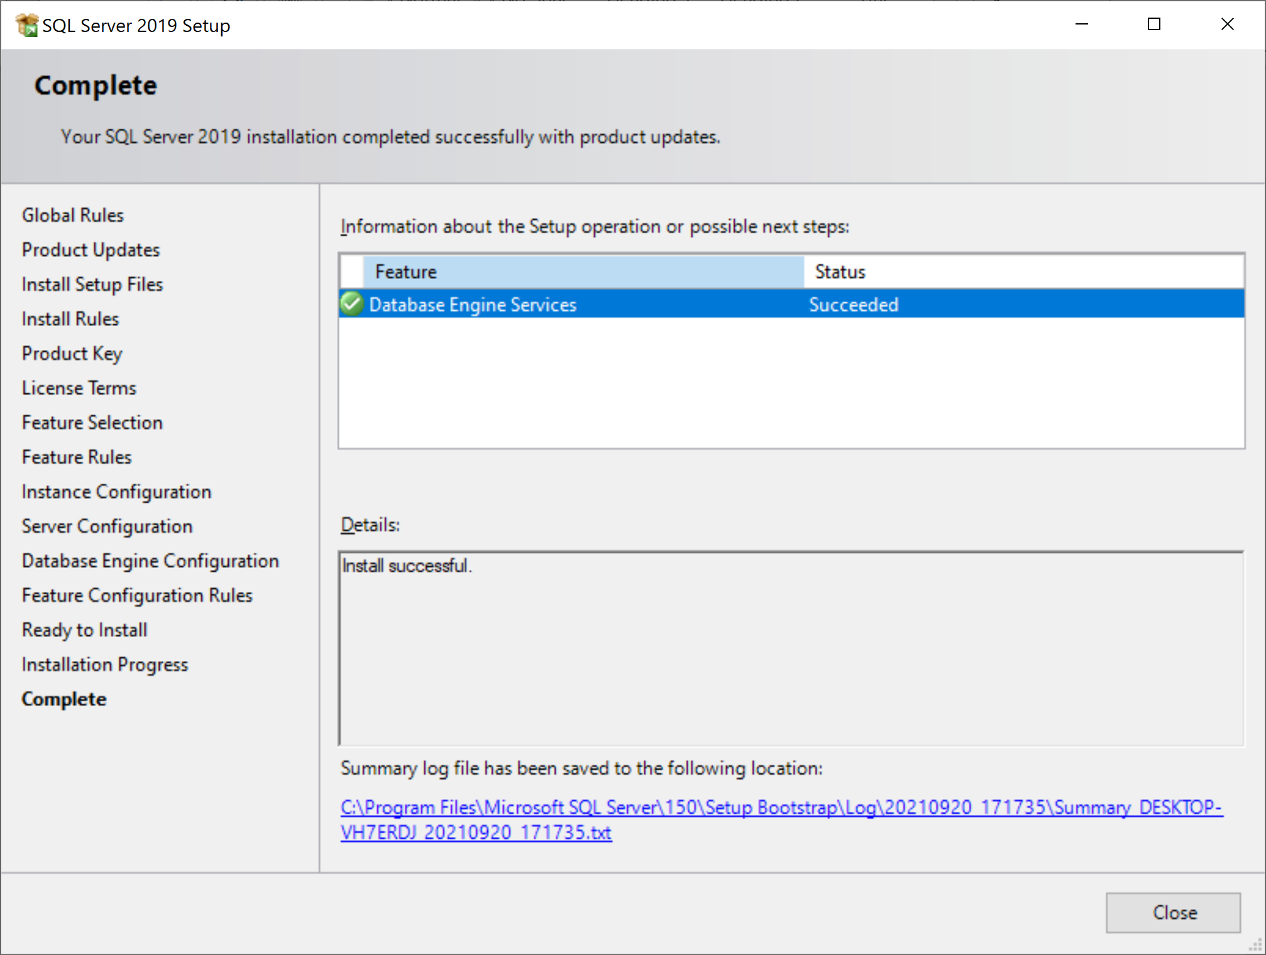

If you kept your fingers crossed, you will notice that the failed feature(s) is installed now. Click Close to complete.

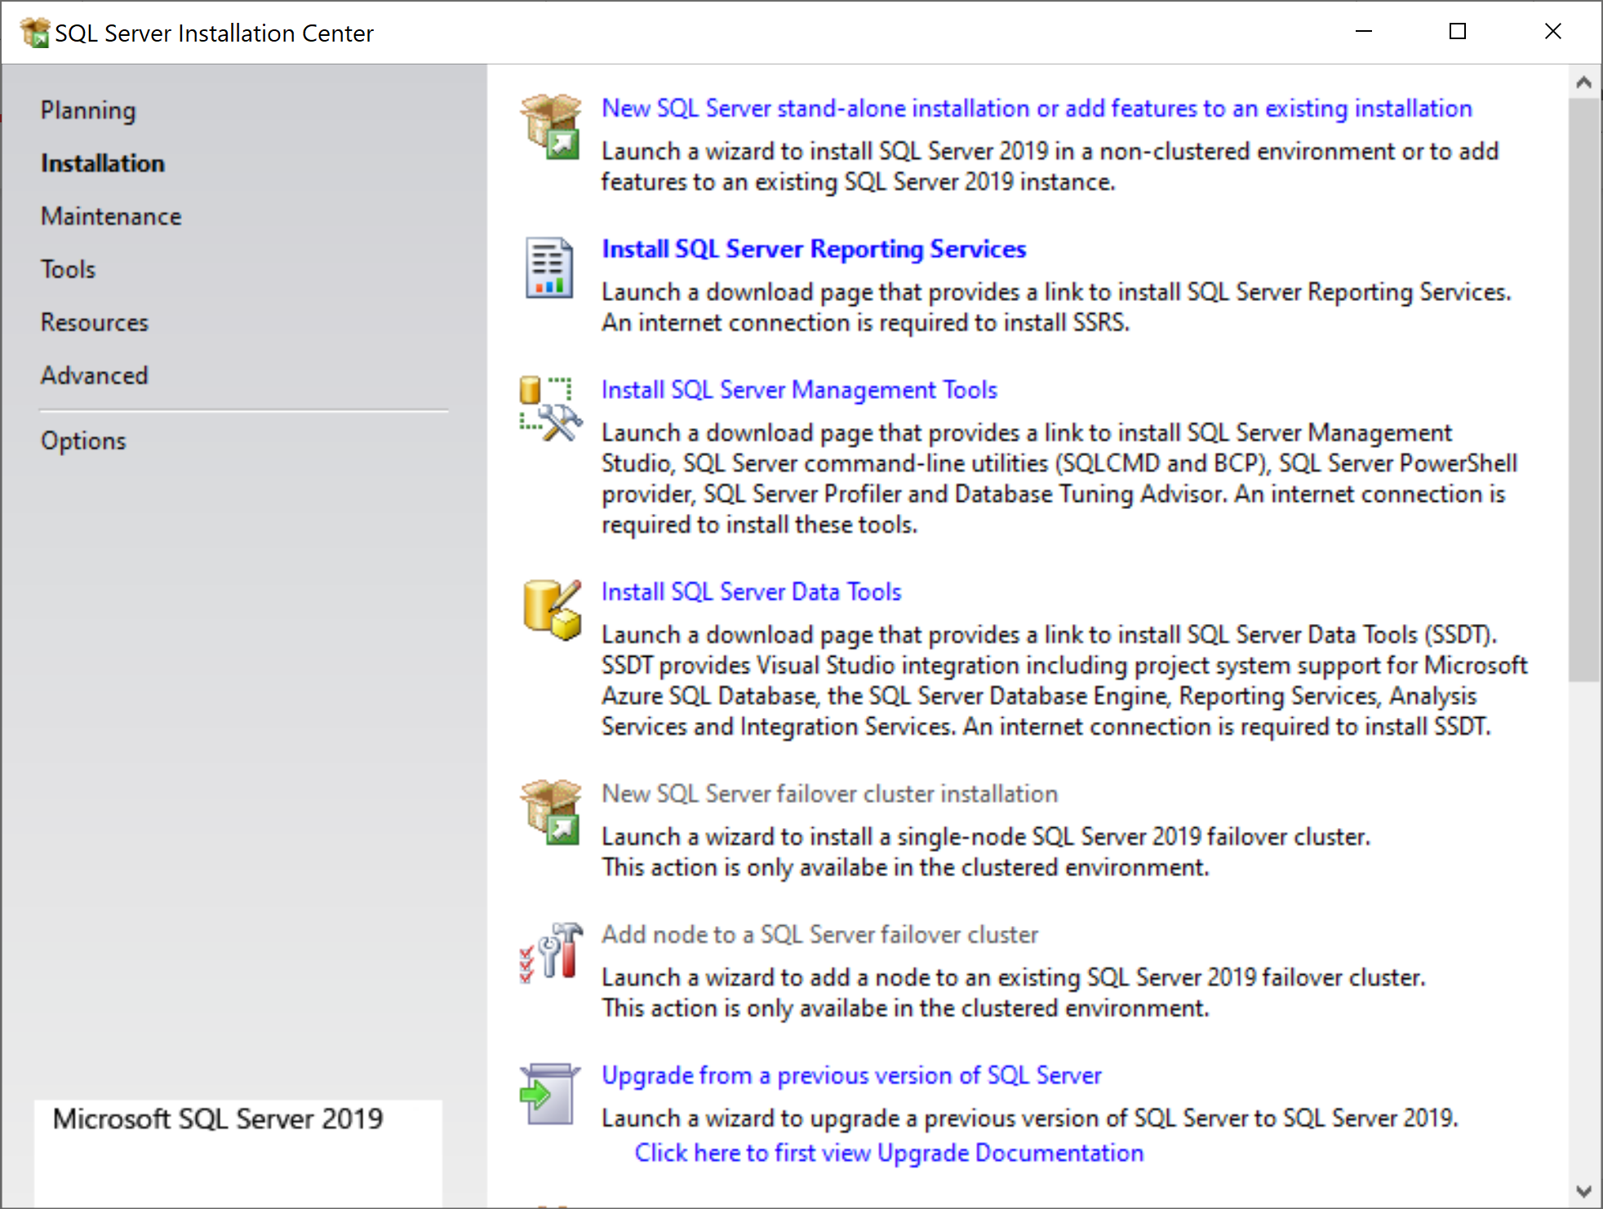If in the future you need to change or install extra features, rerun the SETUP.EXE again. For now we are not done yet with the setup. We also need SQL Server Management Studio.

A student reported the following problem during installation

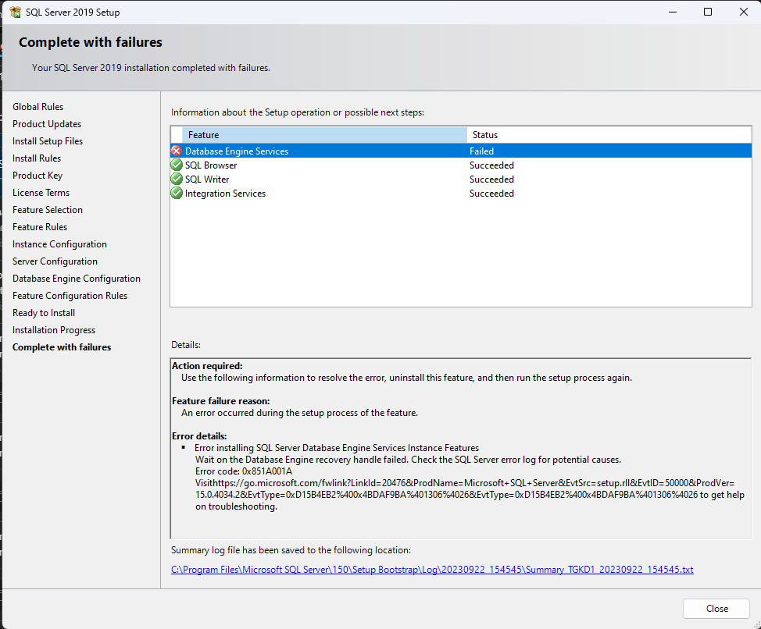

And he found the solution on

<https://learn.microsoft.com/en-us/troubleshoot/sql/database-engine/database-file-operations/troubleshoot-os-4kb-disk-sector-size?WT.mc_id=DP-MVP-5440>

## Installation of SQL Server Management Studio (SSMS)

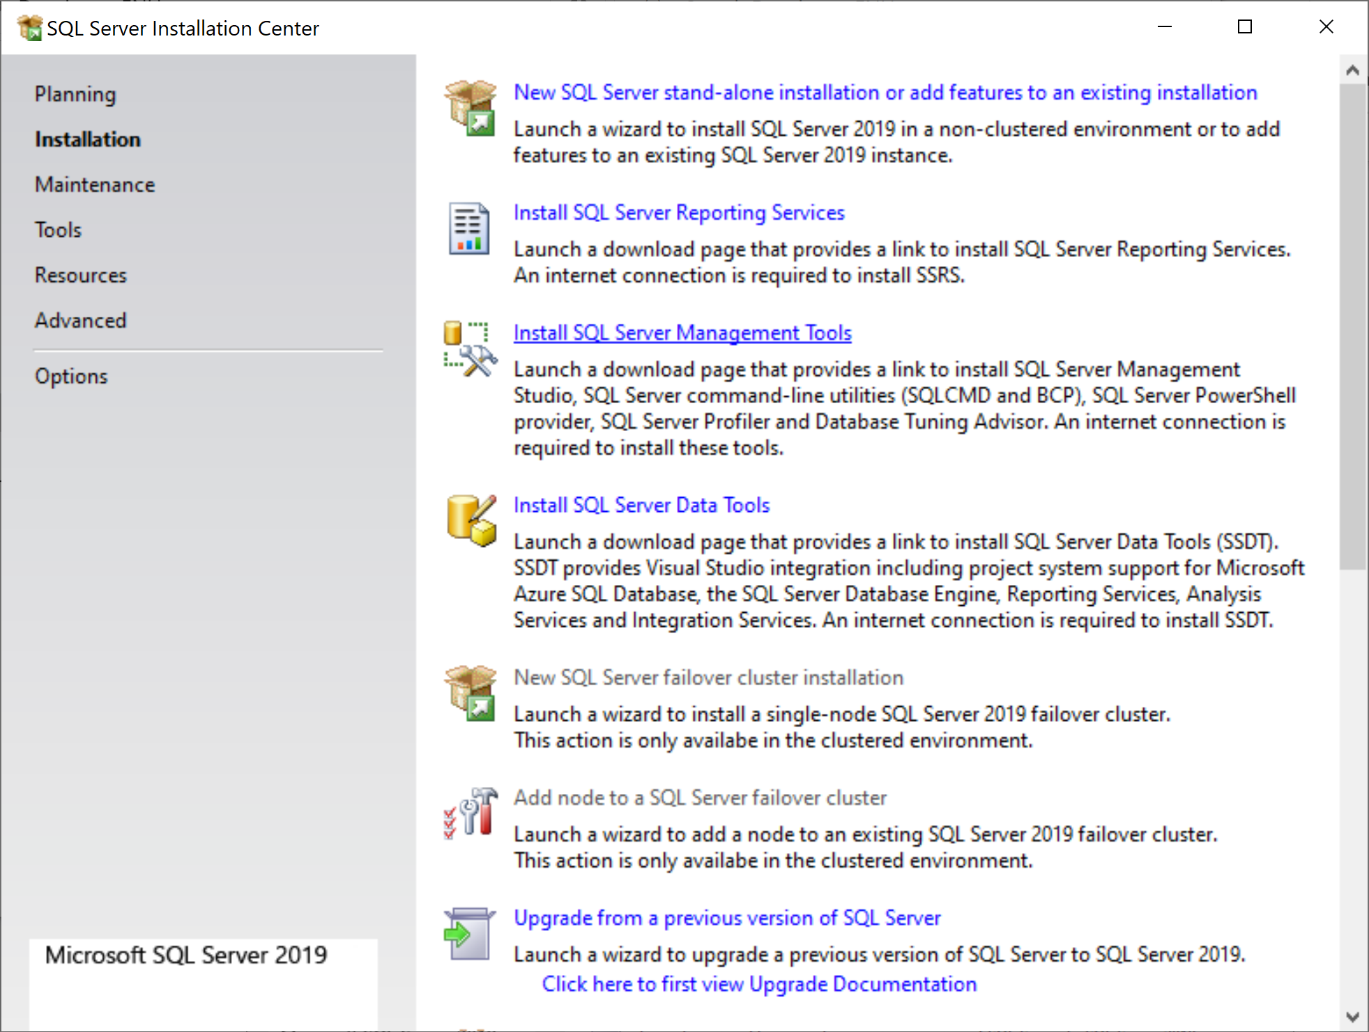

Click Install SQL Server Management Tools.

The browser will open:

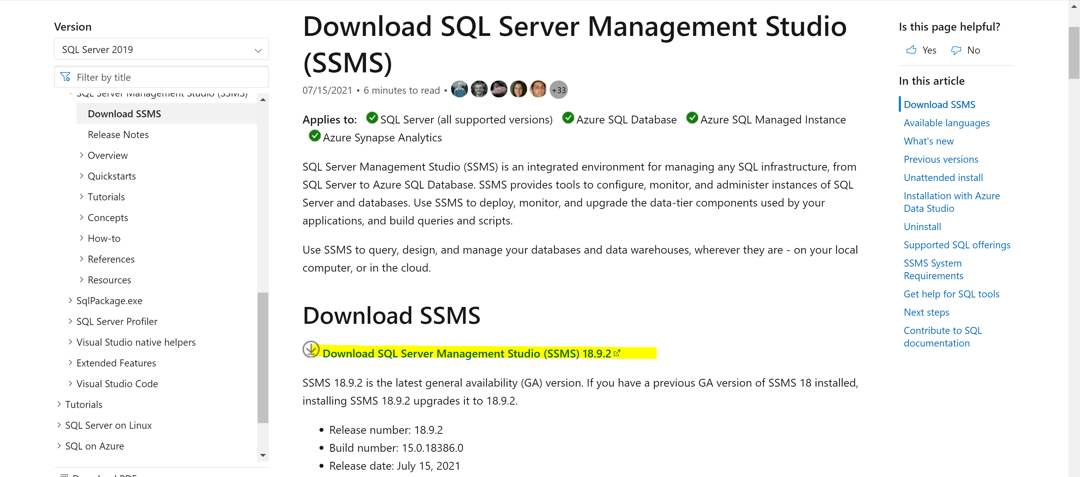

Click ‘Download SQL Server Management Studio’ to download the SSMS and run the setup.

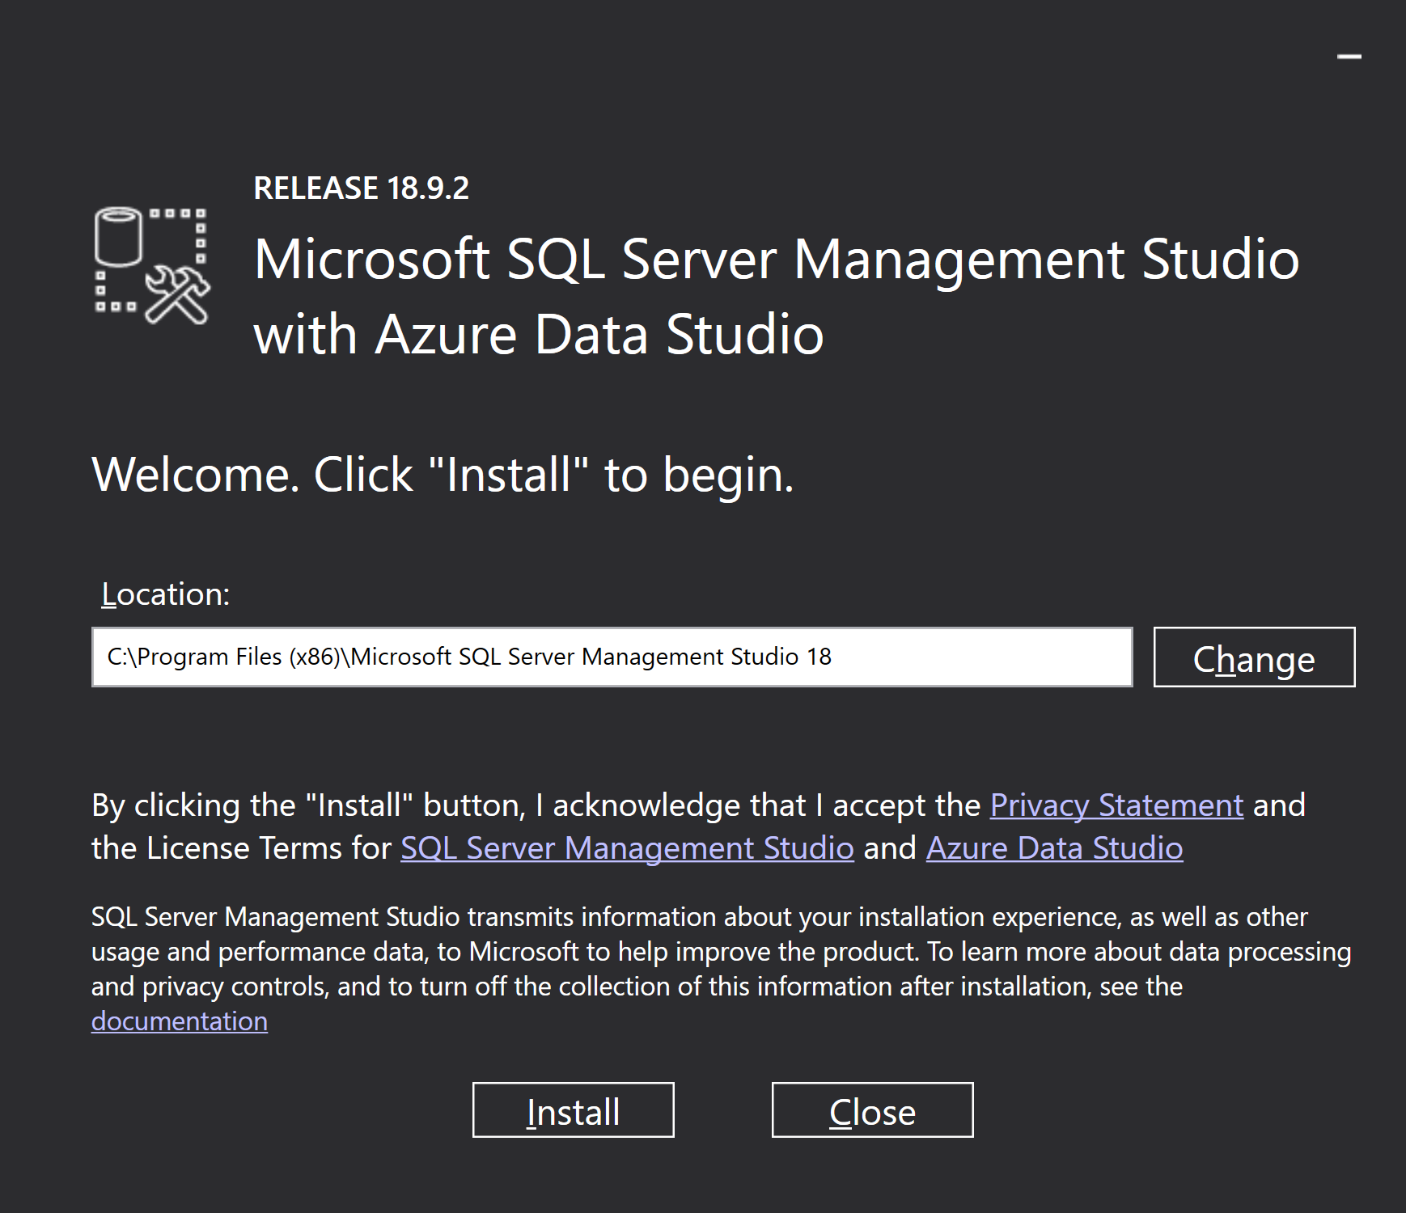

Just click install and wait

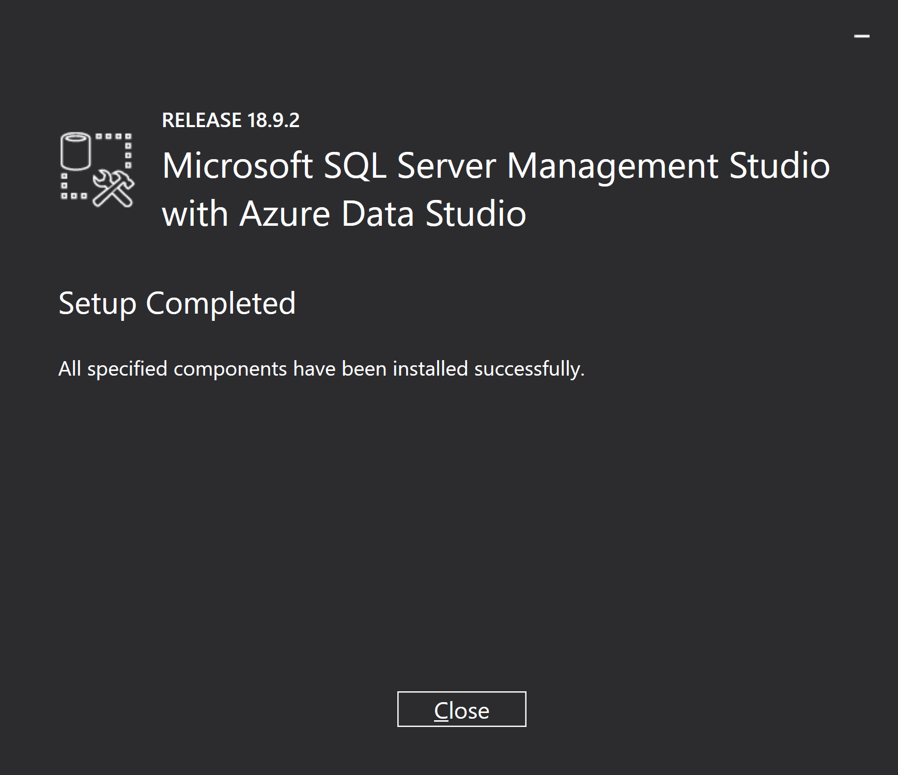

Done!

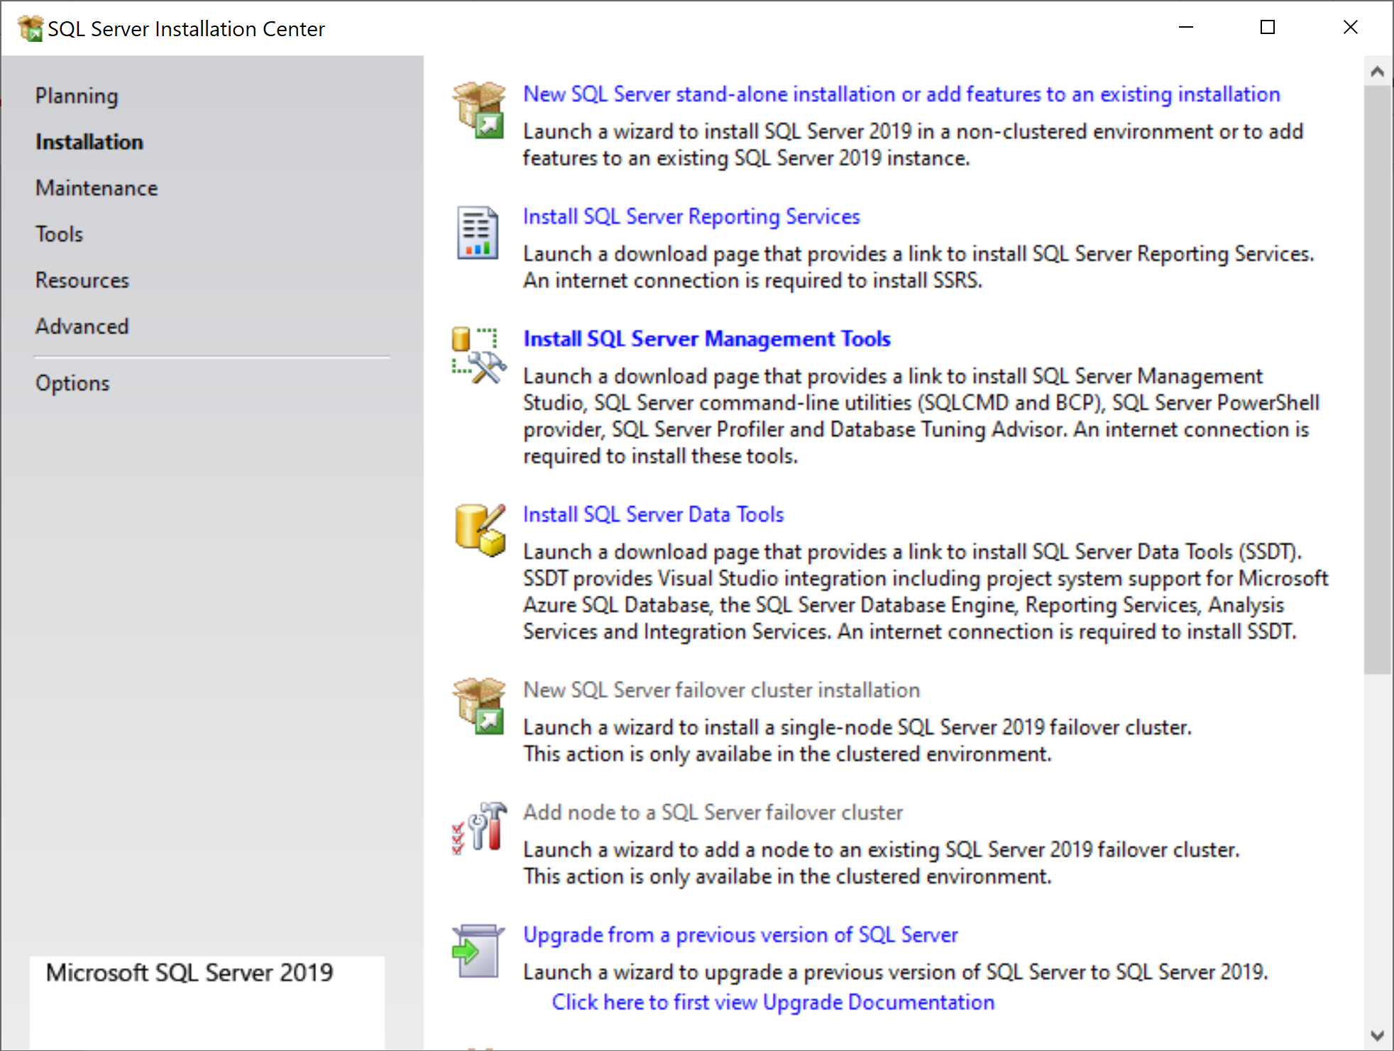

After the completion of the installation of SSMS we are done with the setup now. Keep in mind to rerun the SETUP.EXE again to install additional features (e.g. SSDT of the lectures on BI & DWH). To install SSDT click Install SQL Server Data Tools, or do this later. The process is equal to the installation of SSMS.

To use SSMS, look for Management Studio and run the program.

## Use of SQL Server Management Studio (SSMS): installing and querying a Database

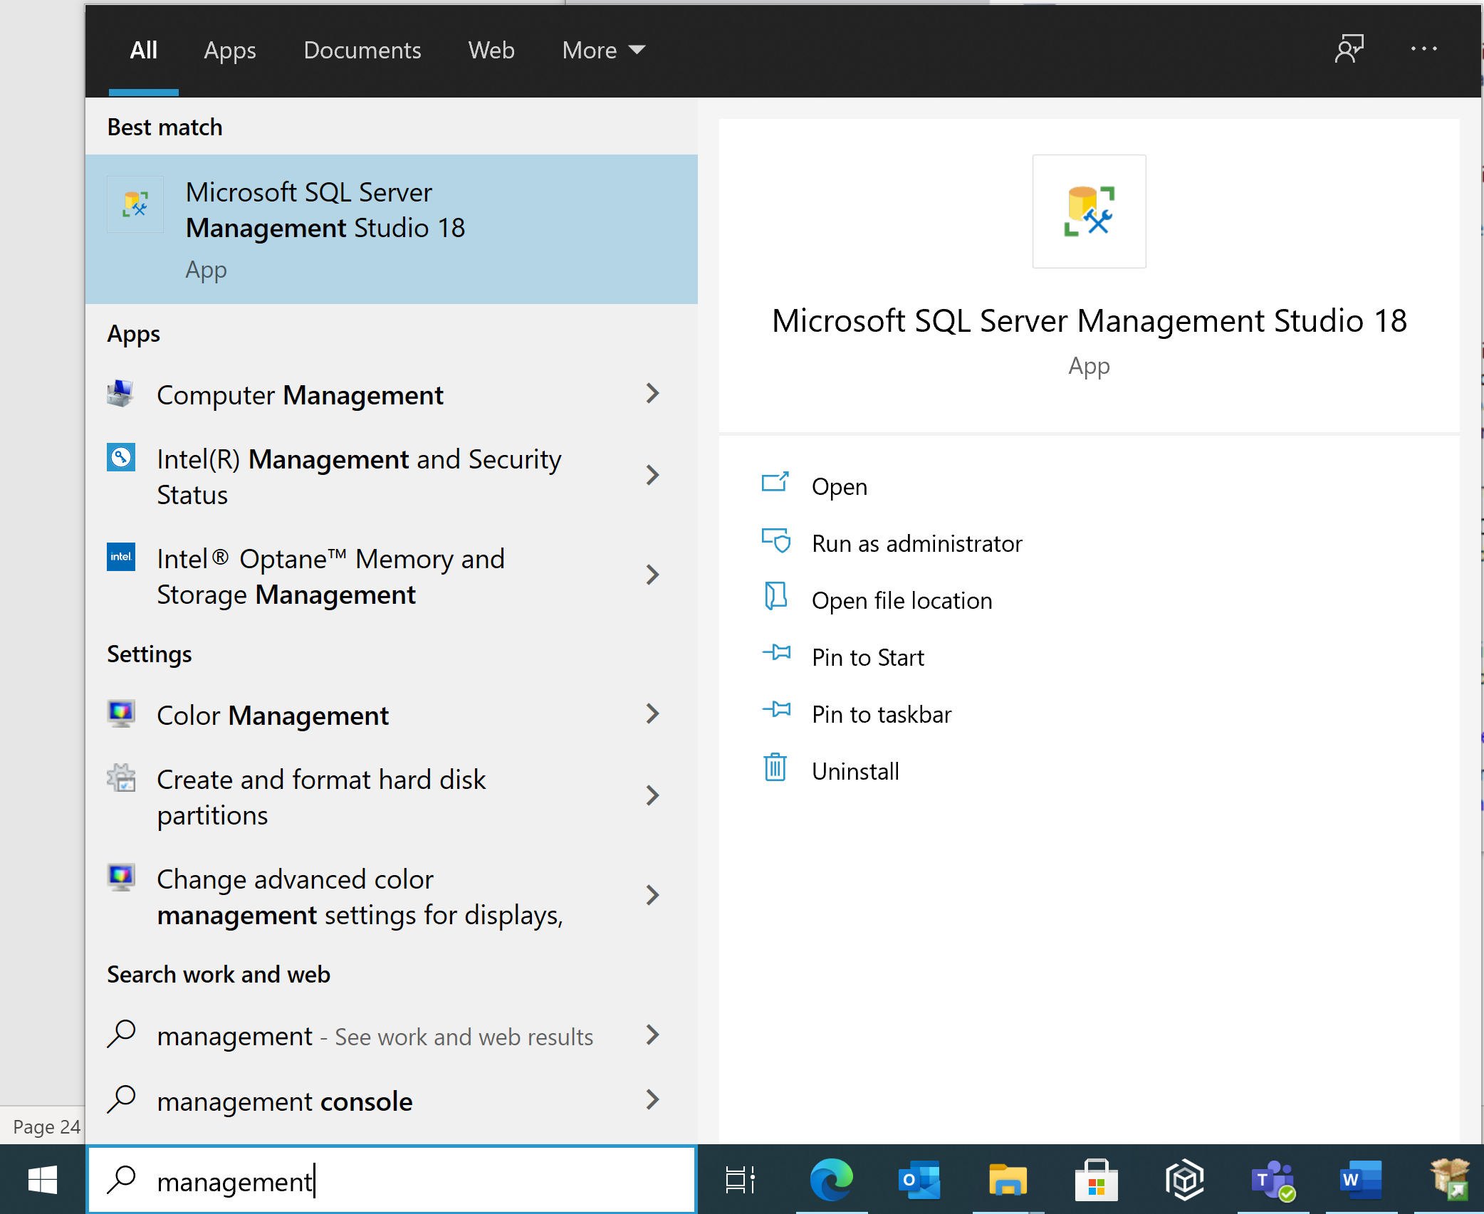

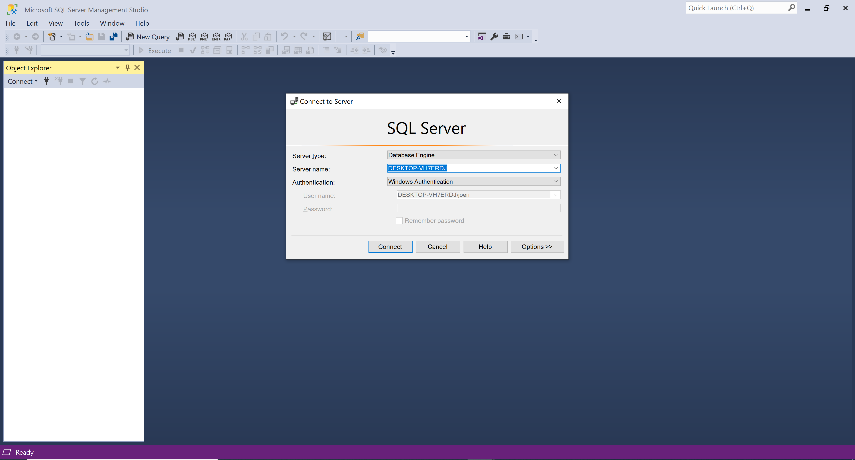

Click ‘Connect’ to login.

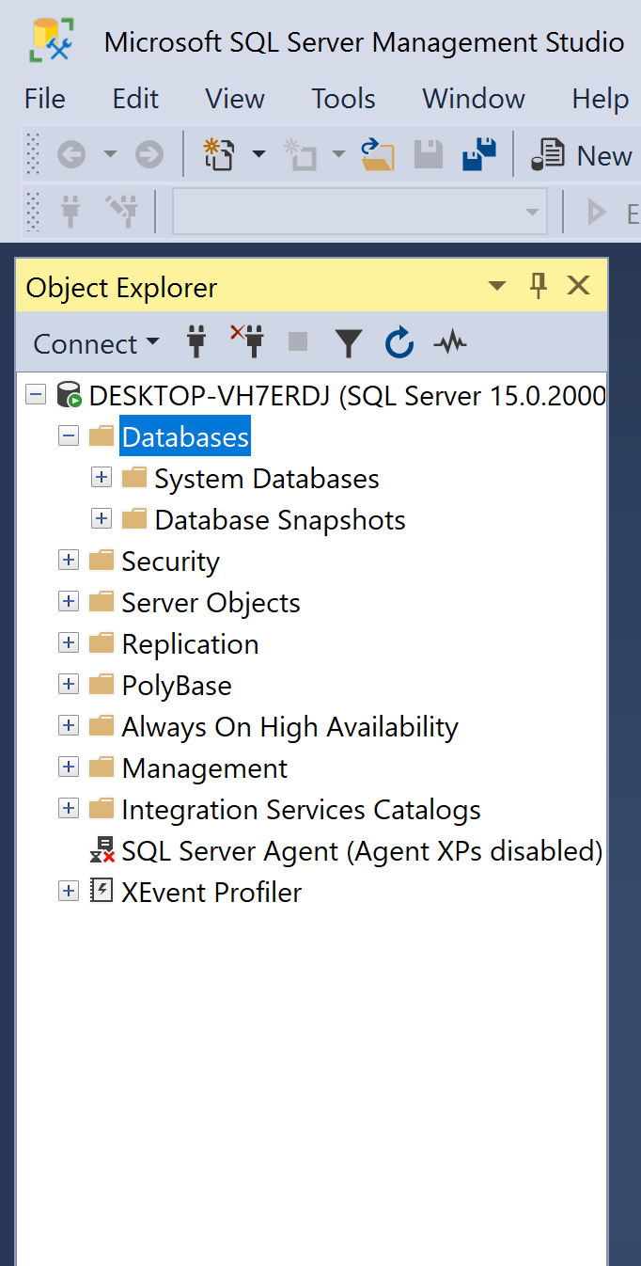

The first time the folder with Databases will be empty.

Download the script for the NorthWind database at Chamilo > Documenten > Scripts.

Open and execute the file Northwind.sql.

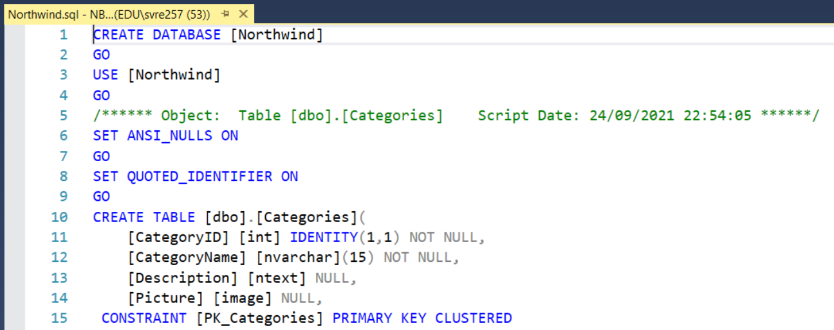

Open a New Query tab and execute:

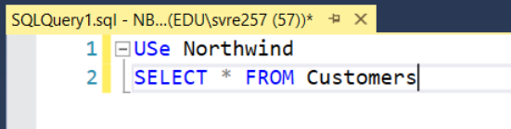

USe Northwind;

SELECT * FROM Customers

Now you can also install the databases Corona and EntertainmentAgency using the scripts on Chamilo.